1. Course three is really a story of something old and something new. Today, we begin our journey and reinforce our learning with function approximation. In a way, this is totally new because we will for the first time discuss objective functions, gradient descent, parameterized functions and generalization discrimination. But, you're totally ready for it.
2. The ideas of exploration exploitation, value functions policies, and many of the elements you've already learned about transfer in a natural way to the function approximation setting. The beginning of course, represents a significant change in perspective.
3. We need to change our focus to learning parameterized functions. We will no longer assume we can store the values for all states in a table. In fact, we can't even guarantee we will see the same state more than once.
4. Instead, we'll learn functions parameterized by set of weights, like a neural network to approximate the values. We won't be able to get this approximation perfect. That means in some states, we'll have to be okay with the value function being inaccurate.
5. Despite this, the move to parameterize value functions is actually overall positive because of generalization. In fact, this better reflects how we learn. You generalize your predictions about how much work you'll have to do in this class based on experience taking other classes. The concepts will become a bit more technical.
6. We will reason about the distribution of states our agents encounter and how that impacts the accuracy of the value function. We'll compute the gradient of objective functions and derive new learning rules.
7. At this point of specialization, you've learned about many things. Now we're going to learn about a bunch of new things. It's easy to get lost. Worse, you might lose sight of which algorithms are most relevant for the given task at hand. To help with this, we've developed a course map.

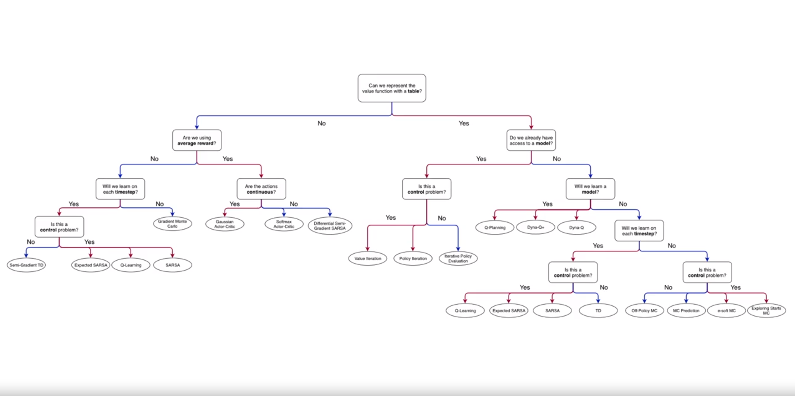

1. The idea is that you should be able to start at the top of the tree and work your way down to the algorithm that best fits your problem. Remember, this is a course map. It does not include all the algorithms in RL, just the ones we have talked about.
2. The map is designed to summarize the algorithms in this course. It is not necessarily the best way to categorize the broader set of algorithms in RL. So use this as a mental model of the course itself. Let's remind ourselves what we've covered in course one and two using the map.
3. We started by assuming the agent could perfectly represent the values in a table. We did this to focus on the fundamental concepts of reinforced learning without getting bogged down by approximation.
4. 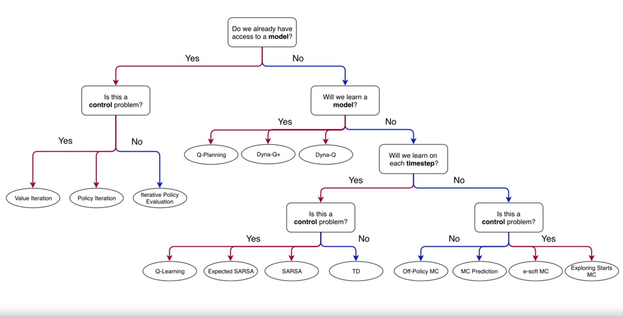
5. .
6. The first RL methods we discussed, use a model of the world that was given not learned. We use dynamic programming methods to compute value functions in iterative policies from the model without ever interacting with the world. See below

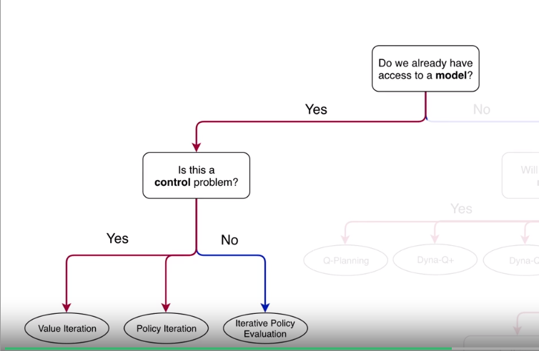

1. The branches of this map show all three DP algorithms that we discussed. In the next course, we covered sample-based methods. We first talked about Monte Carlo methods which must wait until the end of an episode to make updates.
2. .
3. .
4. 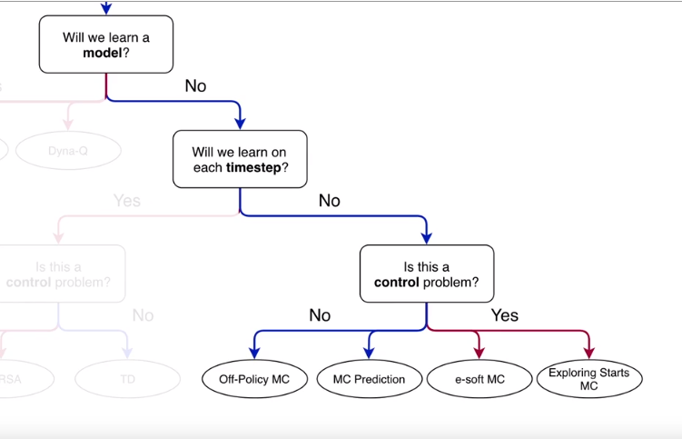
5. We'll learn about two Monte Carlo methods for prediction and two for control. After that, we introduce you to temporal difference learning. This family of algorithms allows the agent to make updates to the value function and policy on each step of the episode.
6. .
7. .
8. .
9. 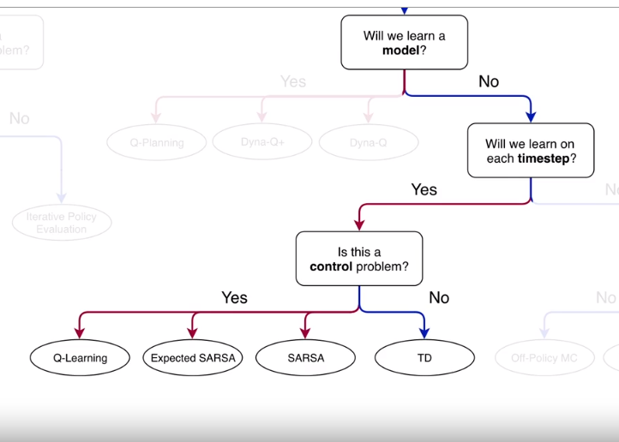
10. .
11. Here, we learned about some of the most widely used algorithms from reinforcement learning including Q-Learning, SARSA and expected SARSA. We finished off course two by looping backup to model these planning methods.
12. We study the Dyna architecture in which the agent learns a model while interacting with the world.
13. .
14. .
15. .
16. 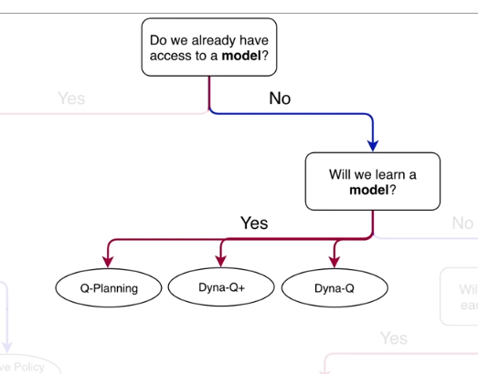
17. .
18. .
19. For course three, we only need the right side of this map. We will first introduce parameters functions and how we can use them to approximate value functions.
20. We will talk about generalization discrimination as well as particular function approximators, including course coding and neural networks.
21. As before, we'll start with prediction and derive new Monte Carlo and TER algorithms using ideas from supervised learning and gradient descent.
22. Then we'll talk about control algorithms for function approximation. This includes expected SARSA and Q-Learning.
23. After that, we will totally blow your mind with a new way of formulating continuing control problems called average reward.
24. We'll finish off course three with parameterized policies. In a nutshell, we can parameterize policies just like we parameterize the value function.
25. .
26. .
27. .
28. 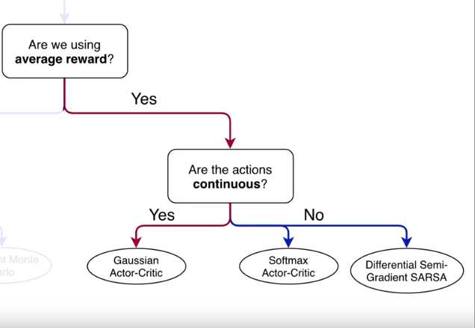
29. .
30. We will discuss how to do this in the average reward setting.
31. By the end of this course, you will know much of what you need to scale RL to real problems. You'll then get to use all this newfound understanding to implement a complete RL system in course four. So let's get to it.
32. .
33. .
34. .
35. .
36. .
37. .
38. .
39. .
40. .
41. 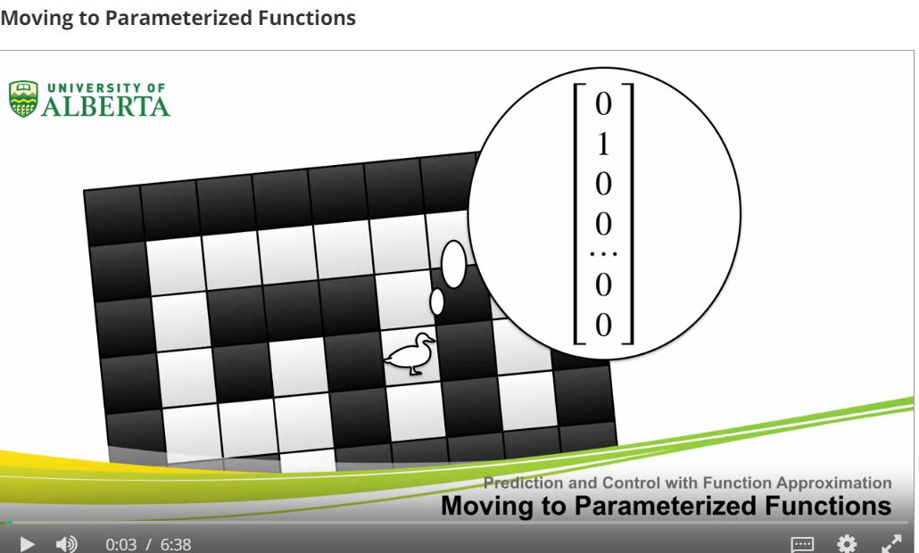
42. .
43. .
44. .
45. Up until now, we've learned about tabular methods. Methods that store table containing separately learn values, for each possible state.
46. In real-world problems, these tables will become intractably large. Imagine a robot that sees the world through a camera.
47. We clearly cannot store a table entry for every possible image. Luckily, this is not the only possibility.
48. 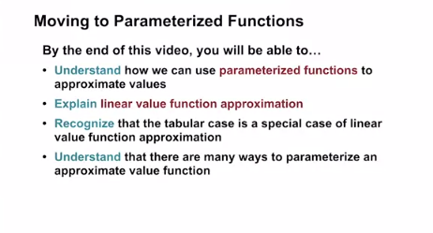
49. Today we'll talk about more general ways to approximate value function.
50. By the end of this video, you'll be able to understand how we can use parameterized functions to approximate values, explain linear function approximation, recognize that the tabular case is a special case of linear value function approximation, and understand that there are many ways to parameterize an approximate value function.
51. In previous courses, we spent a lot of time thinking about how to estimate value functions. So far, our value approximations have always had the same form.
52. For each state, we store separate value in a table. We look at values, and modify them in the table as learning progresses.
53. .
54. .
55. . 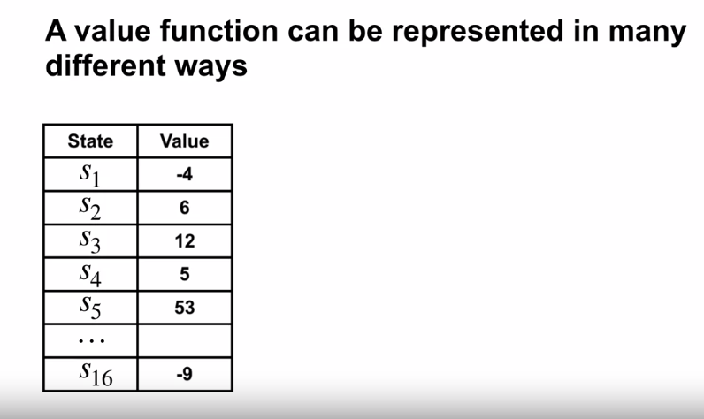
56. But this is not the only way to approximate a value function.
57. In principle, we can use any function that takes a state, and produces a real number.
58. For example in a grid like this, our value function approximation could take the X and Y position, and add them together to produce a value estimate.
59. . 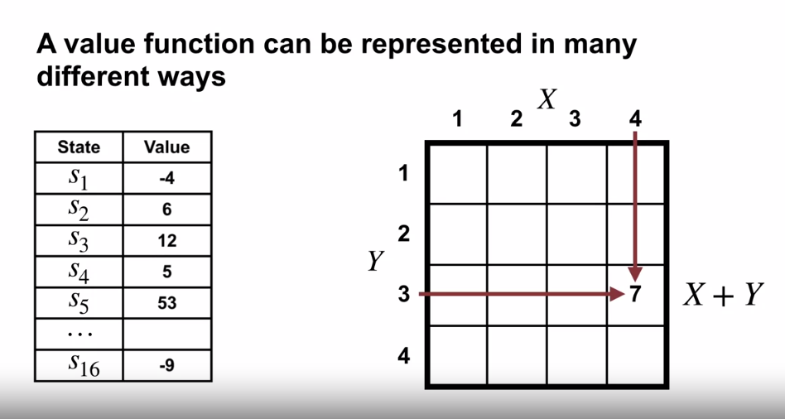
60. This was just to get your intuitions going.
61. We wouldn't want to use this as a value function, because we can't modify the approximation.
62. So we have no way to do learning. This is where the idea of a parameterized function comes in.
63. We incorporate a set of real valued weights, which we can adjust to change the function.
64. For example in this grid, instead of using a fixed sum of X and Y, we could use a function of the form w-1 times X, plus w-2 times Y. The weights w-1 and w-2 parameterize our function.
65. .
66. .
67. .
68. . 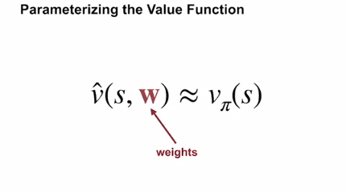
69. They allow us to change the output the function generates. To indicate that this function approximates the true value function, we use the notation v hat. W is a vector containing all the weights that parameterize the approximation.
70. .
71. .
72. . 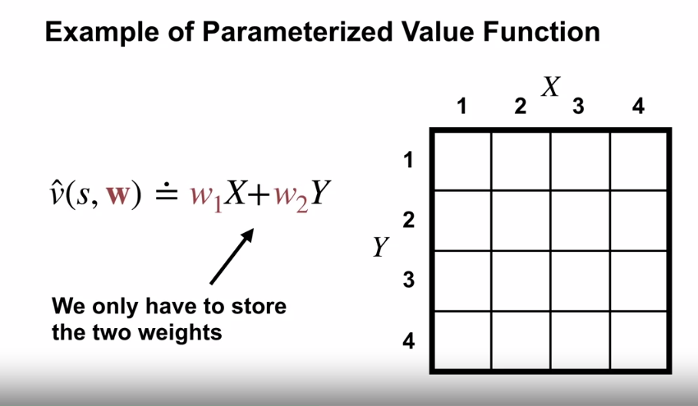
73. .
74. We do not have to store a whole table of values. We only have to store two weights to represent our value function approximation. You can imagine how this compact representation is useful for large state spaces.
75. The tabular representation modifying the value estimates for one state, leaves the others unchanged. This is no longer the case with a parameterized function.
76. Watch what happens to the value estimates of each state as we change the weight w-1. If we change either w-1 or w-2, we will change the value estimate for every state. Now, our learning outcomes will modify the weights, instead of the individual state values.
77. .
78. .
79. .
80. . 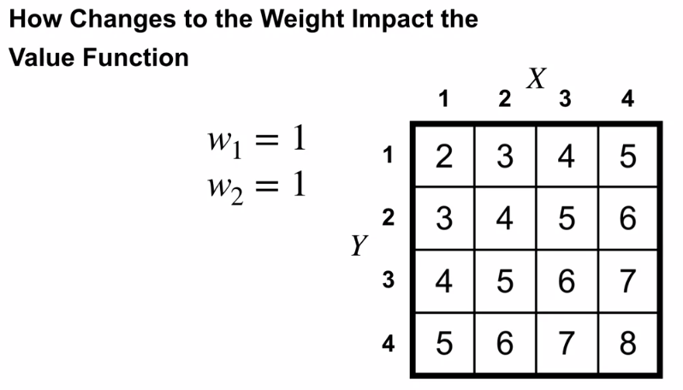
81. . 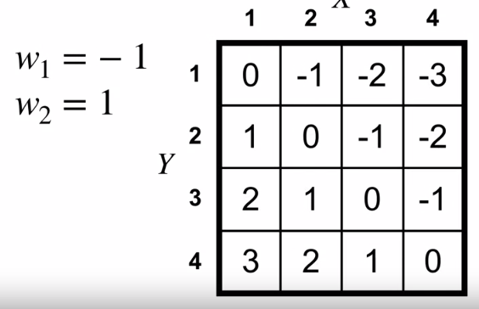
82. . 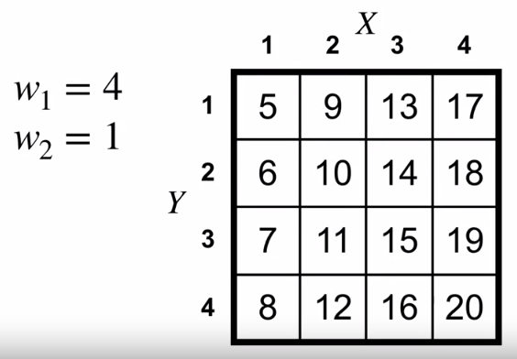
83. The example we just discussed is a special case called linear value function approximation. In this case, the value of each state is represented by a linear function of the weights.
84. .
85. .
86. . 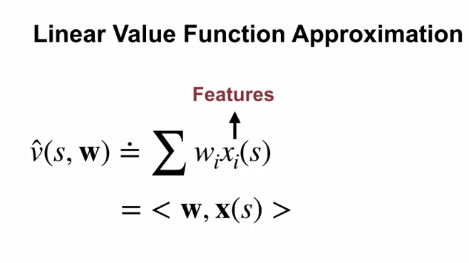
87. .
88. .
89. This simply means that the value of each state, is computed as the sum of the weights multiplied by some fixed attributes of the state called features.
90. .
91. We can express this compactly. We write that the approximate value is given by the inner product of this feature vector, and the weight vector.
92. .
93. We will use bold X of S to denote the feature vector. Our choice of feature impacts the kinds of value functions we can represent.
94. For example, consider the approximation we've discussed so far. With it, we can only represent value functions which changed linearly as a function of the features X and Y.
95. Consider the case where the true value function is given by the numbers on this grid. We cannot represent this as a linear function of X and Y.
96. To get these outer values correct, w-1 and w-2 both need to be zero. However that would mean these inner values are not correct because at least one of w-1 and w-2, must be non-zero for the sum that equal five.
97. .
98. .
99. . 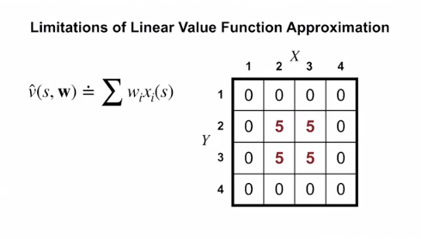
100. But we don't have to use X and Y as features. Linear function approximation relies on having good features. Here X and Y are not good features for this problem. But as you'll see later, there are many powerful methods to construct features.
101. Linear function approximation is actually very general. In fact, even a tabular representation is a special case of linear function approximation.
102. To build a linear value function to represent this tabular value function, we need to define the features. Let's choose our features to be indicator functions for particular states.
103. .
104. .
105. . 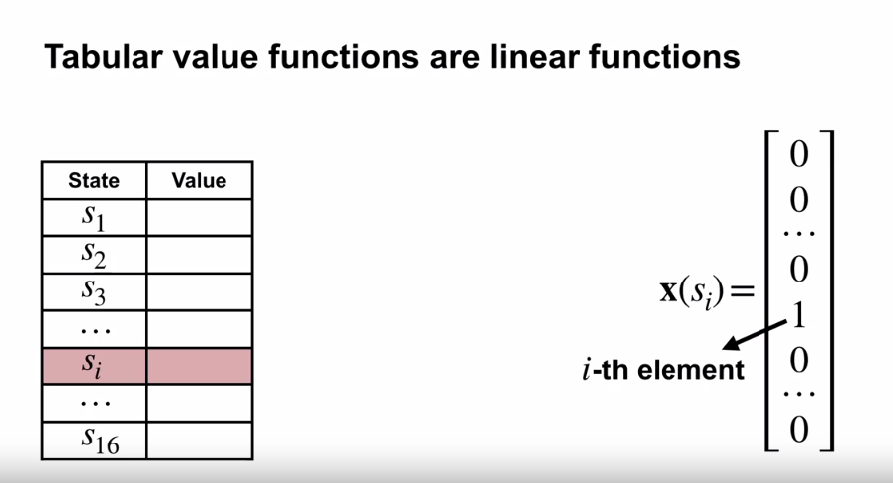
106. .
107. For state S_i, feature i is one and the remaining features are zero. We have 16 features, one for each state. Let's compute the approximate values for a state with these features.
108. .
109. .
110. 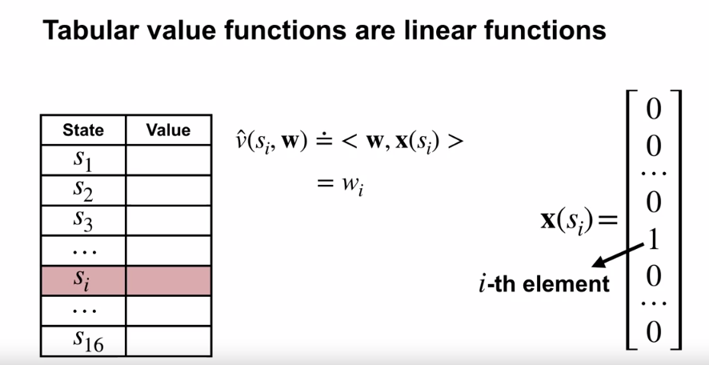
111. .
112. Since all the features are zero except for one of them, the inner product is equal to the single weight associated with that state. Since every state's value is represented by a separate weight, this is equivalent to a tabular value function. These parameterized values are general, and we can consider lots of different types of functions.
113. Neural networks are an example of a non-linear function of state. The output of the network is our approximate value for a given state.
114. The state is passed to the network as the input. All the connections in the network correspond to real valued weights.
115. When data is passed through a connection, the weight is multiplied by its input. This process transforms the input state through a sequence of layers to finally produce the value estimate.
116. We will take a deep dive into neural networks later. That's it for this video. You should now be comfortable with the idea of parameterized functions, and how they might be used to approximate value functions. In the coming weeks, we will discuss how to update these approximate value functions while the agent interacts with the world.
117. .
118. .
119. .
120. 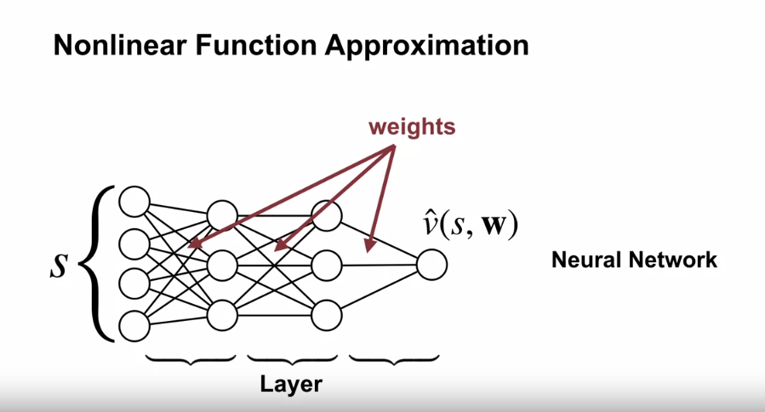
121. .
122. .
123. 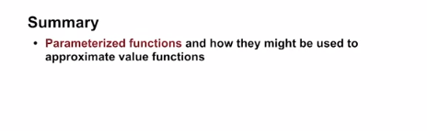
124. .
125. .
126. .
127. .
128. .
129. . Perhaps the most important consideration in function approximation is how it generalizes between states.
130. Generalization is something that humans do naturally. Once a person learns how to drive one car, they don't have to start from scratch to learn how to drive a different car. They also don't have to start from scratch on a different street or when it is raining.
131. We'd like our agents to be able to generalize too.
132. .
133. . 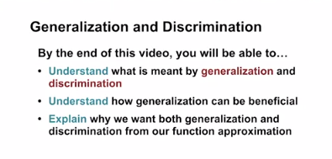
134. .
135. By the end of this video, you will be able to understand what is meant by generalization and discrimination, understand how generalization can be beneficial, and explain why we want both generalization and discrimination from our function approximation.
136. Generalization intuitively means applying knowledge about specific situations to draw conclusions about a wider variety of situations.
137. When we talk about generalization in the context of policy evaluation, we mean that updates to the value estimate of one state influence the value of other states.
138. .
139. Imagine a robot tasked with collecting cans, observing the world through a set of distance sensors. In many locations, it would take the same amount of time to drive to the nearest can. Even though they correspond to different sensor readings, these locations have similar values.
140. Thus, we might want the value function to generalize across those states.
141. .
142. .
143. . 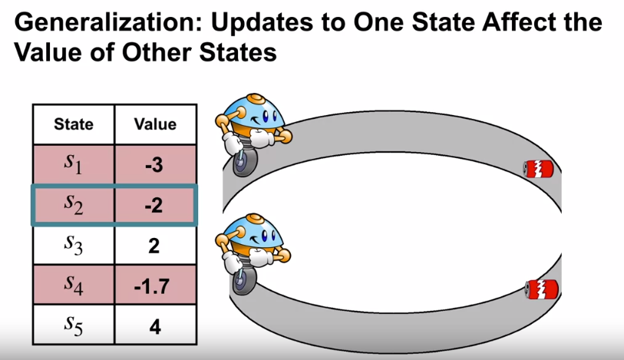
144. .
145. Generalization can speed learning by making better use of the experience we have. You may not have to visit every state as much to get this values correct if we can learn its value from similar states.
146. On the other hand, discrimination means the ability to make the values for two states different to distinguish between the values for these two states.
147. .
148. Going back to the example of a robot collecting cans, imagine it is in a state where a can is three feet away, but behind a wall. Contrast this to a state where a can is three feet away, but with a clear paths to reach it. The robot would want to assign different values to these states. So while it is useful to generalize between states with similar distance to the nearest can, it is also important that we discriminate between states based on other information when it is likely to impact their value.
149. .
150. . 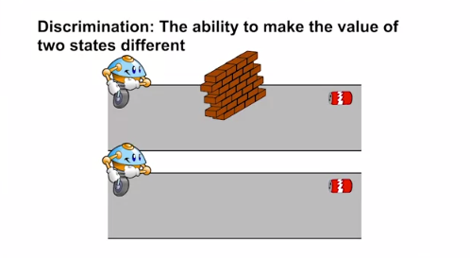
151. .
152. . 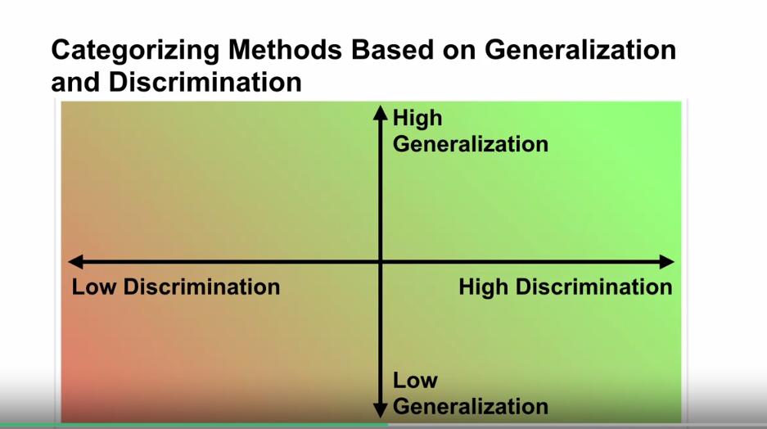
153. .
154. We can visualize the space of possible methods in terms of a two-dimensional plot of generalization and discrimination. The tabular methods we've discussed so far lie down here.
155. .
156. .
157. . 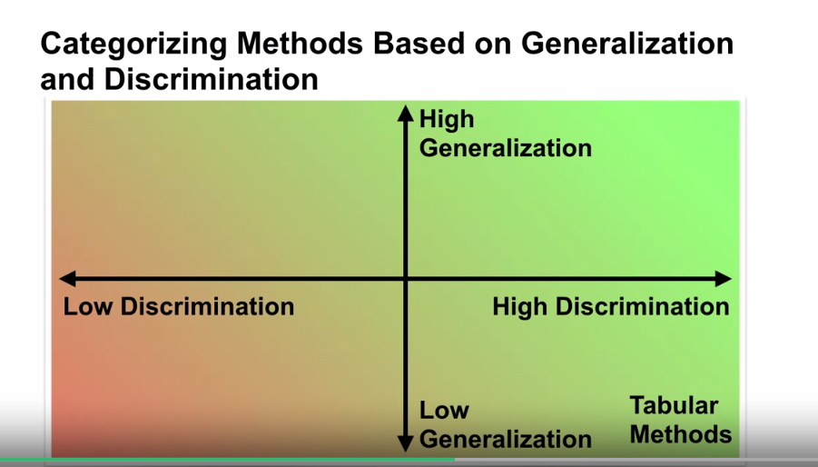
158. .
159. They discriminate between different states perfectly, but do not generalize the learn values at all, each value is represented independently.
160. .
161. .
162. .
163. On the other extreme, we could treat all states as the same. Each update generalizes to all states but cannot discriminate at all.
164. .
165. . 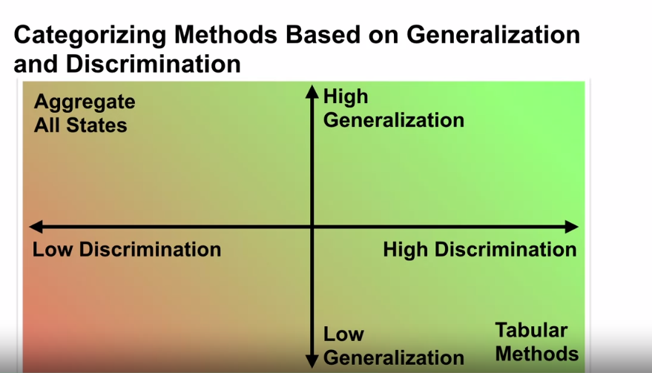
166. .
167. At best, we will be able to learn the average return independent of the current state, this is not very useful.
168. .
169. .
170. .
171. What we would really like is a learning method that achieves good generalization and a good discrimination. Such a method would generalize the learn values to similar states, allowing it to learn faster, but it could also discriminate between states.
172. .
173. . 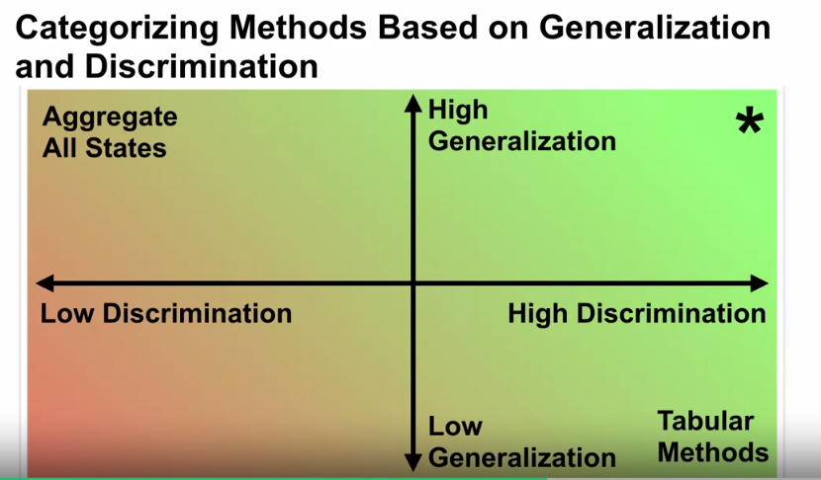
174. .
175. Meaning, with more data, the value function approximation can accurately represent the values.
176. In practice, we are more likely to get a point here, where we trade off some level of discrimination for generalization.
177. .
178. .
179. . 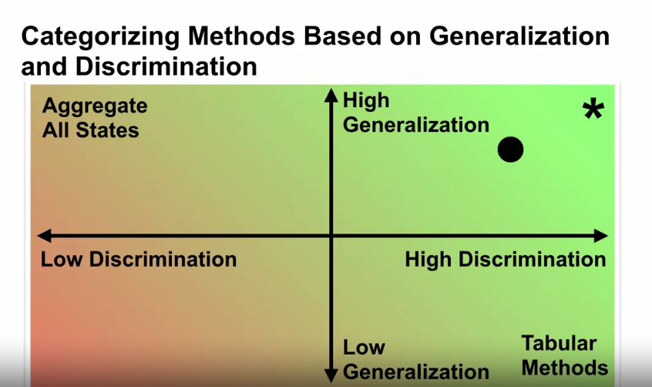
180. .
181. For example, we might combine similar states together and represent their values with one number.
182. .
183. .
184. .
185. .
186. .
187. 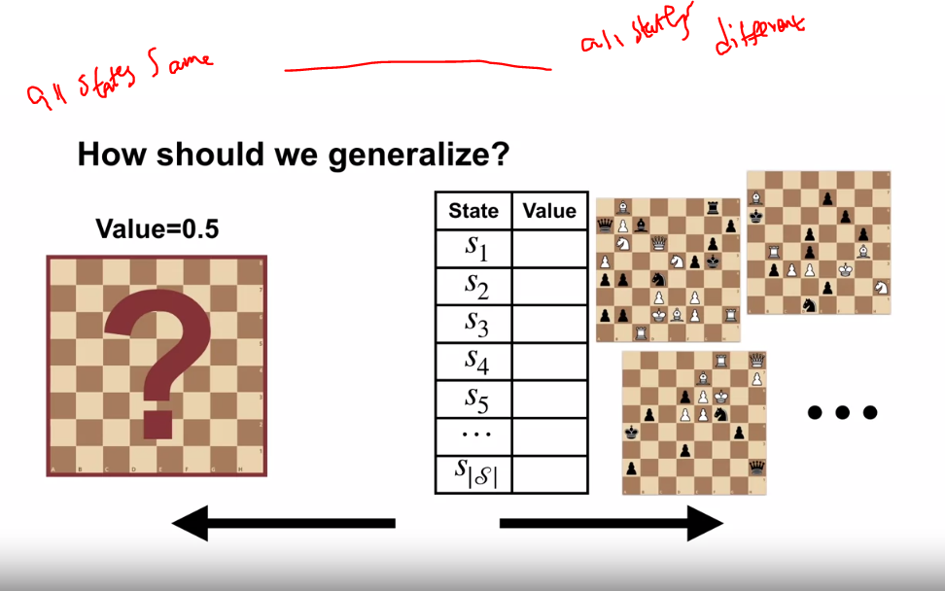
188. .
189. To build some more intuition, let's look at the game of chess as a concrete example. Take the extreme case where we treat all states as the same. This value corresponds to the probability of winning regardless of the state of the game. With equally matched players, this number might be 50 percent. On the opposite extreme, we have the tabular case, where we treat every state as totally different. This is fine for small problems, but in a game like chess, it is impractical to even enumerate all the possible states. There are approximately 10 to the 46 states. Further, imagine how long it would take to individually learn the value of all these states.
190. .
191. We obviously want something in-between where we generalize between states with similar probabilities of winning. Identifying these similarities to get such groupings is a difficult question with no single answer.
192. .
193. .
194. .
195. .
196. How we generalize can have a major impact on the performance of our algorithms, and as a central topic in machine learning and reinforcement learning.
197. That's it for this video. You should now understand that tabular representations provide good discrimination but no generalization. Generalization is important for faster learning, and having both generalization and discrimination is ideal. Though at practice, there's typically a trade off. Throughout the next few modules, we will visit these concepts as we examined particular function approximators.
198. .
199. .
200. .
201. 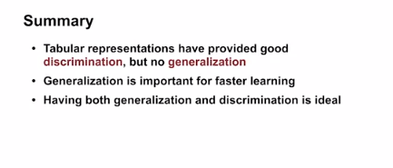
202. .
203. .
204. .
205. Supervised learning methods learn a function from a set of input target examples. This is very different from reinforcement learning.
206. But supervised learning methods can be useful for handling parts of the reinforcement learning problem.
207. By the end of this video, you will be able to understand how value estimation can be framed as a supervised learning problem, and recognize that not all function approximation methods are well suited for reinforcement learning.
208. Supervised learning involves approximating a function given a dataset of input target pairs.
209. For example, imagine we had a list of house prices along with a set of attributes for each house. We could use supervised learning to train a function to take the attributes of a house as input and estimate the expected price of the house.
210. .
211. 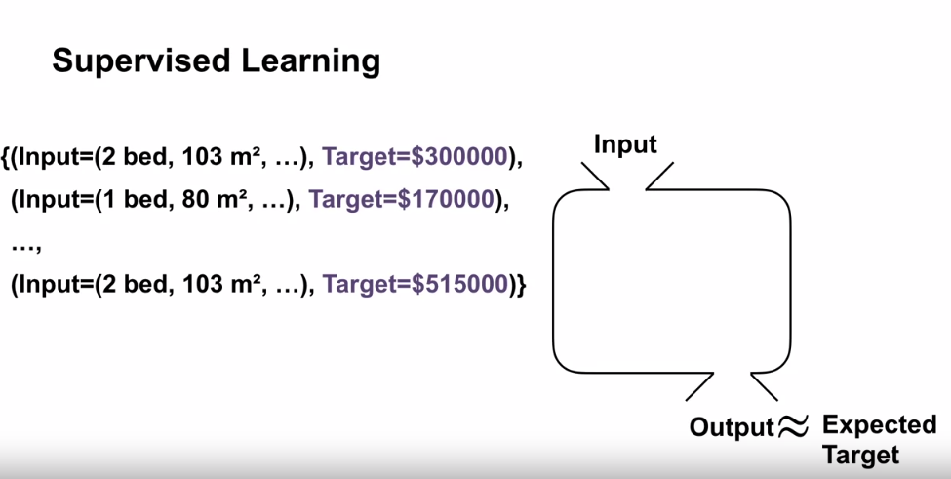
212. The hope is that the function learned will also generalize to approximate the expected price for houses that were not in the training set. This parameterized function can be represented in a variety of ways.
213. For example, a neural network. The problem of policy evaluation in reinforcement learning can be framed similarly.
214. This similarity is most obvious in the case of Monte Carlo methods.
215. .
216. Remember, the Monte Carlo methods estimate the value function using samples of the return.
217. .
218. We can think of this as an example of a supervised learning problem, where the input is the state and the targets are the returns.
219. .
220. .
221. .
222. 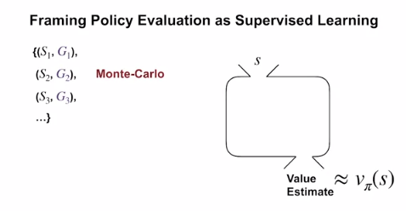
223. .
224. By training on enough examples, we hope that the output of our learn function will be a close approximation of the expected return. In other words, the value in each state.
225. TD can also be framed as supervised learning. In this case, the targets are the one-step bootstrap return. In principle, any function approximation technique from supervised learning can be applied to the policy evaluation task.
226. .
227. .
228. . 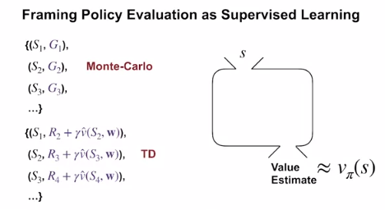
229. .
230. However, not all are equally well-suited. Let's see why. In reinforcement learning, an agent interacts with an environment and continually generates new data. This is often called the online setting.
231. To distinguish it from the offline setting where the full dataset is available from the start and remains fixed throughout learning.
232. If we want to use a function approximation technique, we should make sure it can work in the online setting.
233. .
234. . 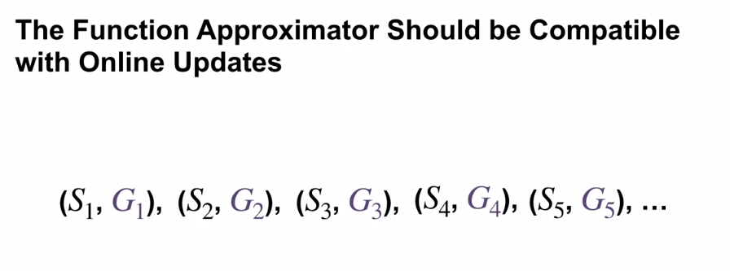
235. .
236. Some methods are not compatible with the online setting because they are either designed for a fixed batch of data or there are not designed for temporally correlated data, and the data in reinforcement learning is always correlated.
237. TD methods introduce an additional complication when applying techniques from supervised learning.
238. TD methods use bootstrapping, meaning that our targets now depend on our own estimates. These estimates change as learning progresses and so our targets continually change.
239. This is different than supervised learning where we have access to a ground truth label as the target.
240. .
241. . 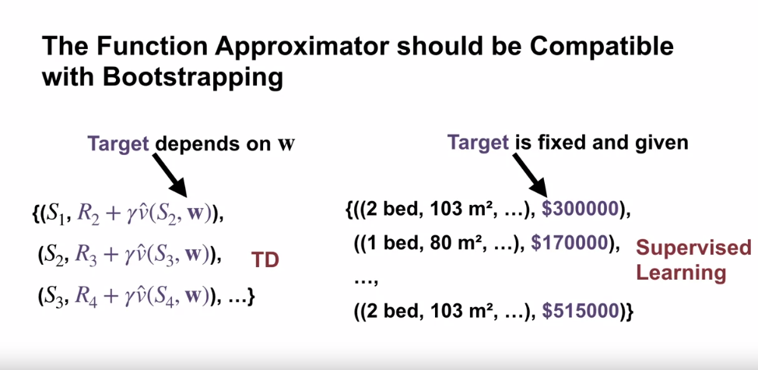
242. .
243. For example, the price of a house does not depend on our estimate nor does it change when we change our estimates.
244. .
245. Supervised learning methods are typically not designed for changing targets nor targets computed from the agent's own estimates.
246. .
247. That's it for this video. You should now understand how we can frame the policy evaluation task as a supervised learning problem. But that not all methods from supervised learning are ideal for reinforcement learning, we will need methods that are compatible with online updating and bootstrapping. See you next time.
248. .
249. 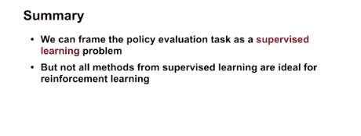
250. .
251. .
252. .
253. .
254. We discussed how we can frame value estimation as a Supervised Learning problem. In Supervised Learning, an important step is to find the objective to optimize. In this video, we'll be more precise about the objective we would like to optimize.
255. .
256. 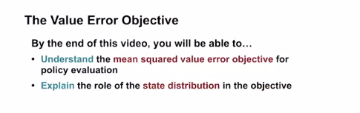
257. After watching this video you will be able to: understand the Mean Squared Value Error objective for policy evaluation and explain the role of the state distribution in the objective.
258. Let's start by imagining an idealized scenario. We get a sequence of pairs of states and true values. We want to use this data to find a parameterized function that closely approximates V Pi.
259. .
260. . 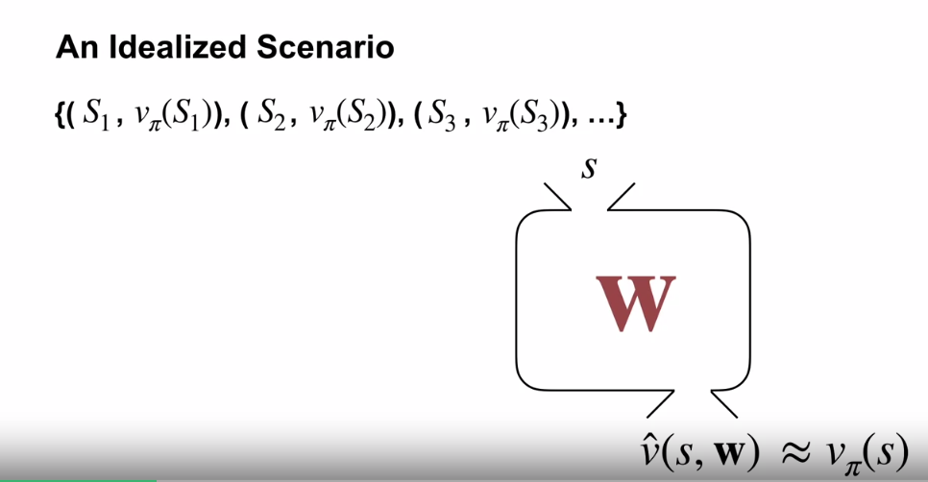
261. .
262. .
263. We will do this by adjusting the weights so that the output of the function closely matches the associated value for a given state.
264. In general, we can't expect to perfectly match the value function on all states. The function approximately we choose will limit the value functions we can represent.
265. To make our goal precise, we need to specify some measure of how close our approximation is to the value function.
266. Consider a linear value function approximation denoted by V hat. Here to keep the visualization simple, the state is a single-dimensional and continuous.
267. Let's plot our estimate of the value function. Now, imagine the true value function looks like this. Clearly, our approximation of V Pi is not perfect, but how far off is it?
268. .
269. .
270. .
271. . 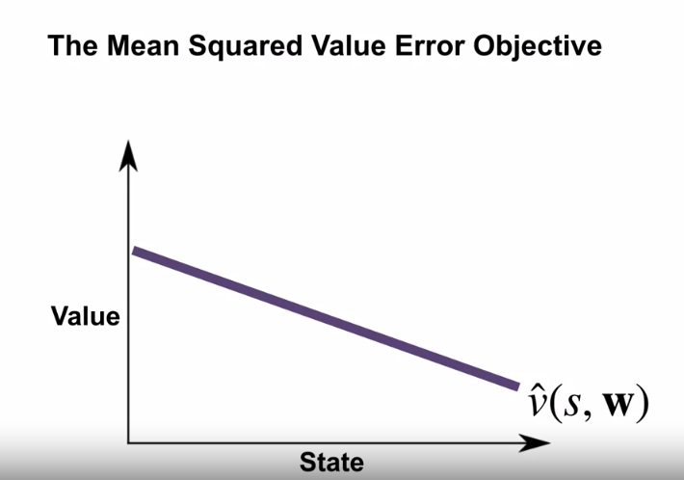
272. .
273. 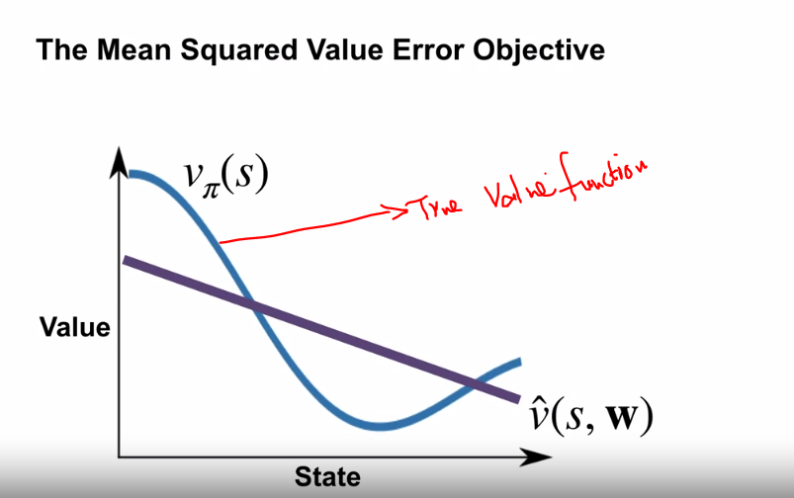
274. .
275. Let's define this more precisely. Let's start by defining a measure of the error between the value of a state and the approximate value. A natural choice is the squared error. That is; the squared difference between the value and our approximation.
276. .
277. .
278. .
279. . 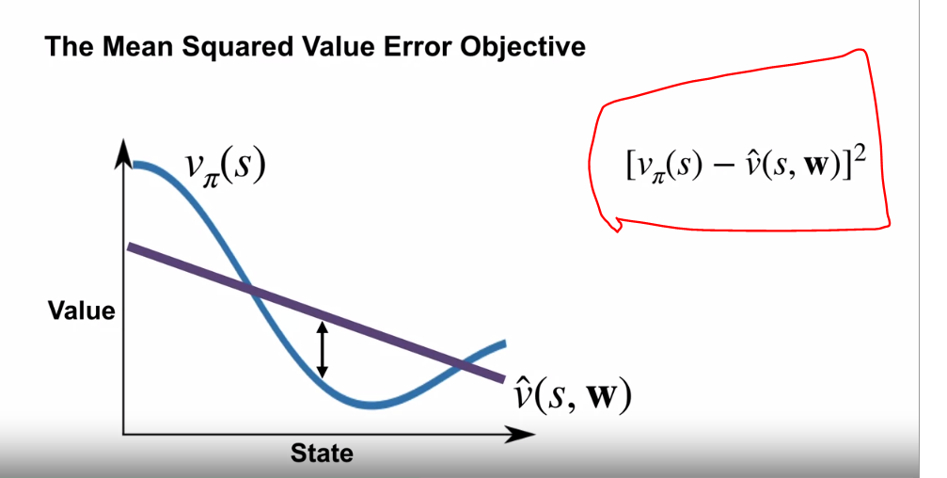
280. However, this is not enough to define an objective for function approximation. Making the estimate more accurate in one state will often mean making it less accurate in another state.
281. .
282. .
283. .
284. . 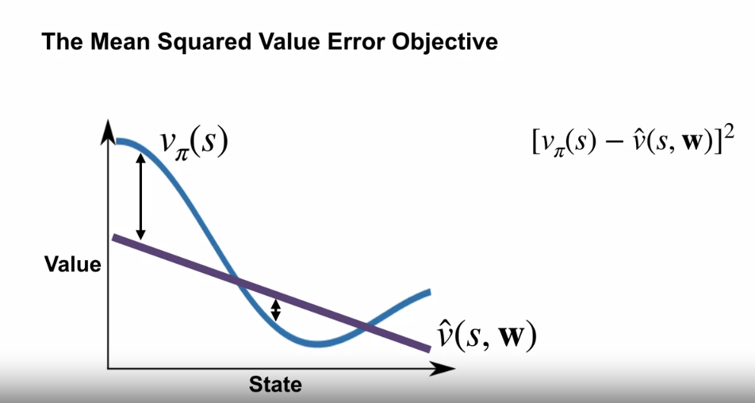
285. .
286. For this reason, we need to specify how much we care about getting the value right for each state. We will call that Mu of S. More about that in a second.
287. .
288. .
289. . 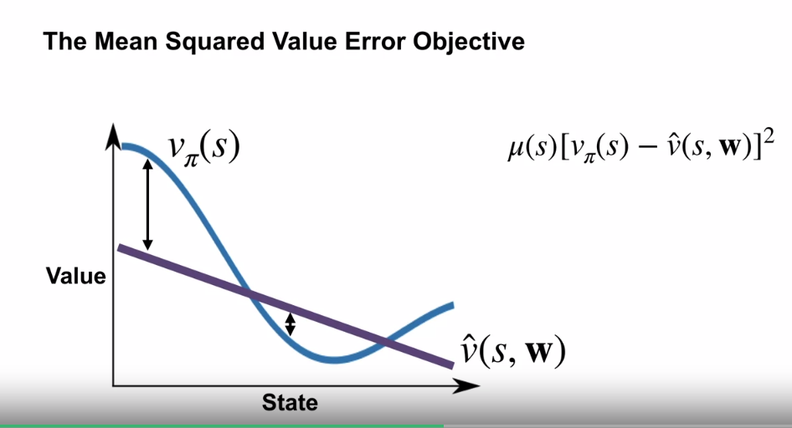
290. We can now write our full objective as a sum of the squared error over the entire state space where each state is weighted by Mu. We call this objective the Mean Squared Value Error. Back to Mu.
291. .
292. .
293. .
294. . 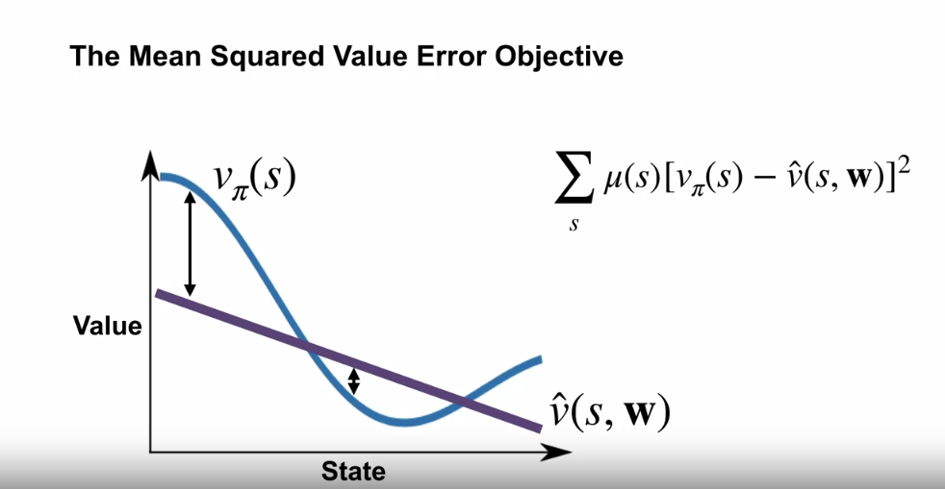
295. What should we pick from Mu of S? Remember, Mu of S should tell us how much we care about each state.
296. .
297. .
298. . 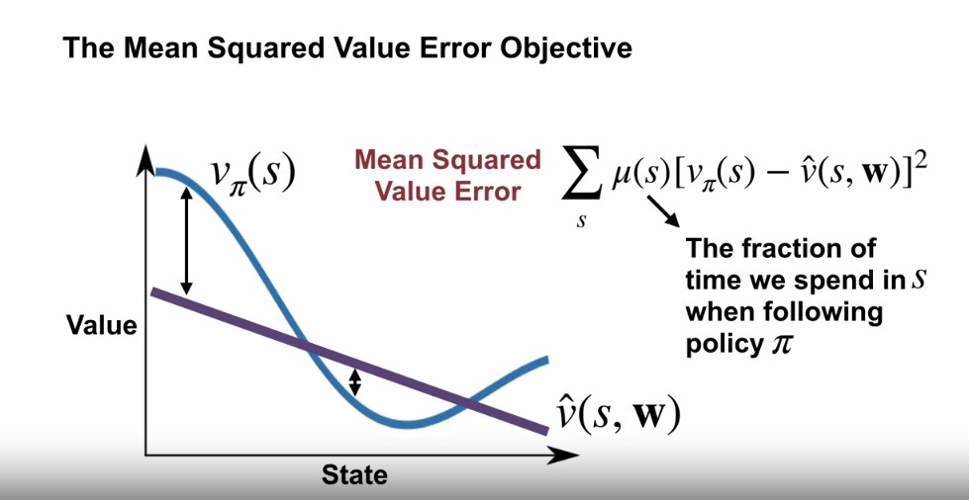
299. A natural measure is the fraction of time each state is visited under the policy. That means we want to minimize the average value error for the states we visit while following Pi.
300. The states that the policy spends more time in have a higher weight in the objective.
301. .
302. We care less about errors in the states the policy visits less frequently.
303. Mu of S is a probability distribution as shown on the slide.
304. .
305. .
306. . 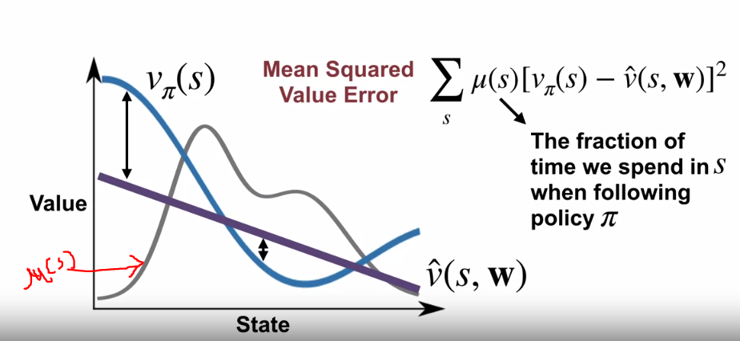
307. In this example, the policy spends little time at the extremes of the state space. This means, under the Mean Squared Value Error, we allow the value approximation to have higher error in those states. Now remember the purpose of defining this objective.
308. .
309. .
310. .
311. We want to adapt or weights to make the Mean Squared Value Error as low as possible. From now on we will call this objective VE bar.
312. Changing the weights in one way may increase the value error while changing them in a different way might decrease the value error.
313. .
314. .
315. .
316. . 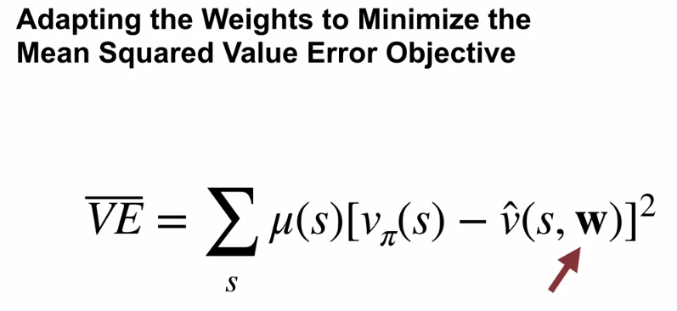
317. In the next lecture, we'll talk about how we can use gradient descent to incrementally adjust the weights. That brings us to the end of this video. You should now understand why policy evaluation under function approximation requires us to specify an objective. The Mean Squared Value Error is one possible objective. See you next time.
318. .
319. .
320. 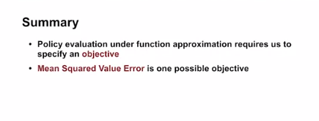
321. .
322. .
323. .
324. . 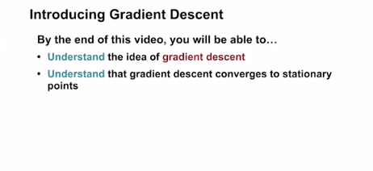
325. .
326. . Previously we looked at how value function estimation can be framed as supervised learning. We made this precise by specifying an objective.
327. Now we want to figure out how to find solutions to this objective.
328. Today we'll talk about a general strategy for minimizing objectives called gradient descent.
329. In the following videos, we'll cover specific algorithms for the objectives in reinforcement learning.
330. After watching this video, you will be able to, understand the idea of gradient descent, and understand that gradient descent converges to stationary points.
331. We want to minimize the mean squared value error, to make our value estimates close to the true value function.
332. Recall that our value estimate is given by a function of the state, parameterized by a set of real-valued weights, W. These ways determine how the value's computed for each state, changing the weights will modify the value estimate for many states.
333. .
334. . 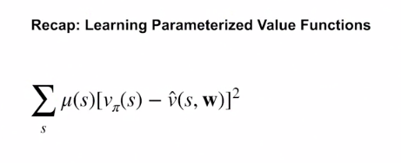
335. .
337. We have to think about how to change the weights to minimize the overall value error. To do that, we'll need a little bit of calculus.
338. Hopefully, you remember the idea of a derivative from calculus. Here we've plotted a function f, with scalar parameter W. The derivative tells us how to locally change W to increase or decrease f.
339. .
340. 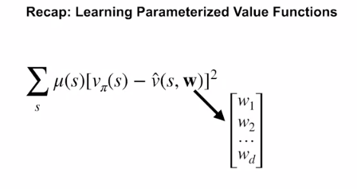
341. The sign of the derivative of f at a particular point W, indicates the direction to change W to increase f. The magnitude of the derivative indicates the slope of the function f at the point W. That is, how quickly f will change as we vary W. Here the derivative is positive.
342. If we move W in this direction, we increase f. At this other point, the derivative is negative, it is pointing in a direction to decrease W. But this direction still indicates how to increase f.
343. If we move W in this direction, it increases f. If we were to move it in the negative of this direction, it would decrease f. If f is privatized by more than one variable, then W is a vector. In this case, we need to introduce the idea of a gradient to describe how f changes as the vector W changes. 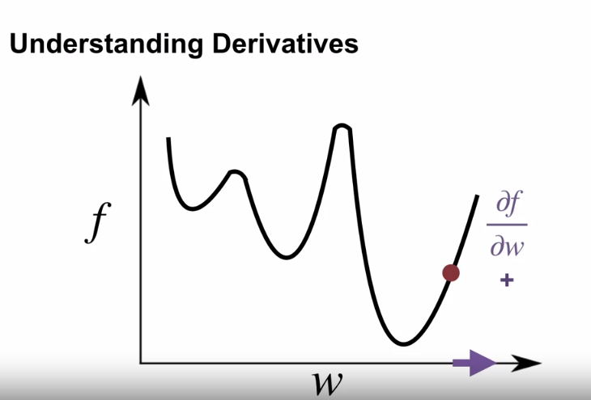
344. The gradient is a vector of partial derivatives, indicating how a local change in each component of W affects the function. Notice that the gradient has to be the same size as the weight vector. The sign of each component of the gradient specifies the direction to change the associated component of W, in order to increase f.
345. .
346. .
347. . 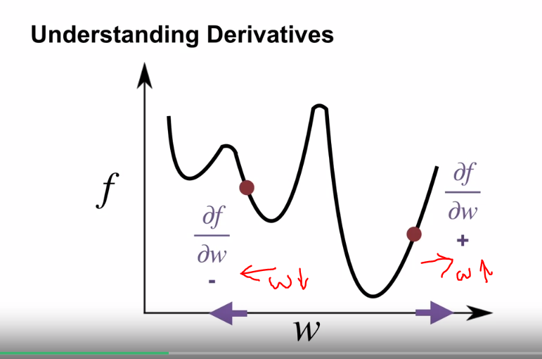
348. The direction is either positive or negative. The magnitude of the component specifies how quickly f changes, as W moves in that direction. If the function is very steep in one dimension, the magnitude will be high.
349. If it is very flat the magnitude of the gradient in that dimension will be low. Regardless of the magnitude, the gradient gives the direction of steepest descent. It provides the direction to change W, so that locally f is maximally increased. To give a specific example, let's derive the gradient of a linear value function.
350. .
351. .
352. . 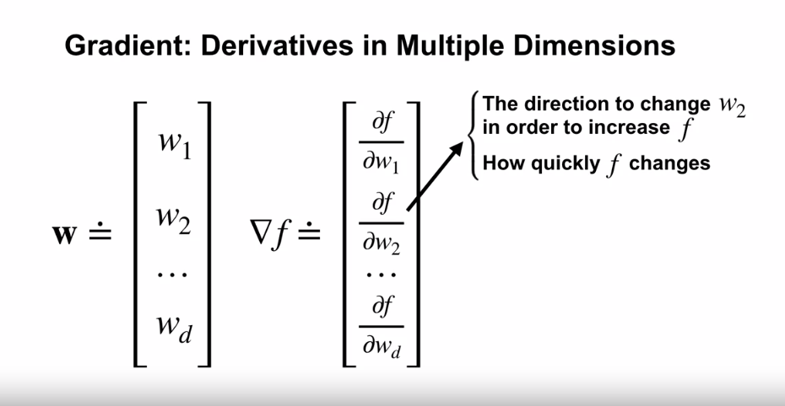
353. .
354. 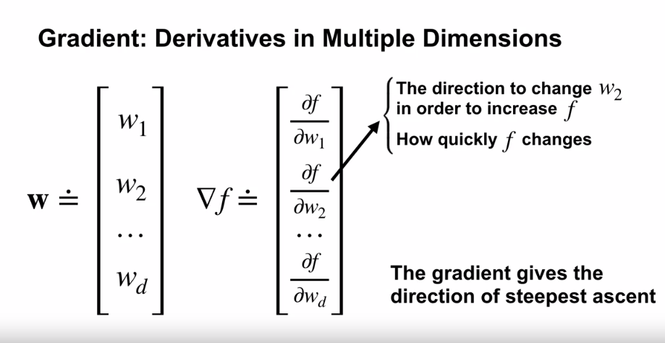
355. Remember, a linear value approximation is just an inner product of the weights with the feature vector for the state. The partial derivative of that with respect to a single weight, is just the feature associated with that weight. .
356. .
357. .
358. .
359. .
360. . 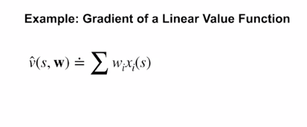
361. Remember, the features themselves do not depend on the weights. This means the gradient of a linear value approximation is simply the feature vector for that state. Our objective is a function of the weights.
362. .
363. .
364. . 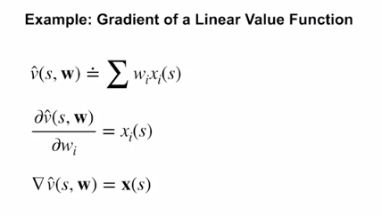
365. For example, the mean squared value error is a function of the weights because it is a function of V hat, and V hat is a function of the weights. Our goal is to adjust the weights to make the objective small. Here we have a hypothetical plot of our objective.
366. .
367. .
368. . 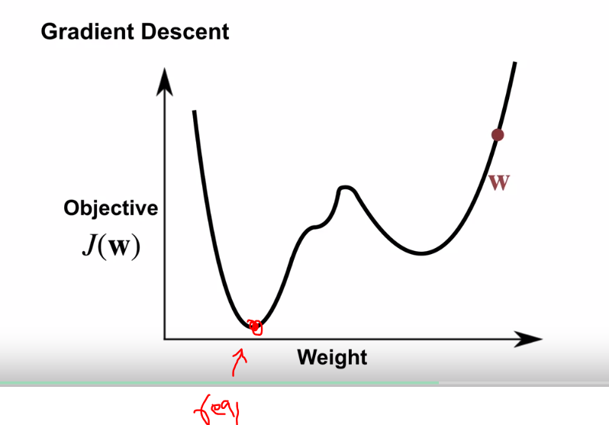
369. To keep things simple, let's say our function is parametrized by a single weight. The x axis corresponds to this weight, and the y-axis to the objective value for this weight. Because we have a single weight, this means our gradient is just a scalar derivative.
370. .
371. .
372. .
373. . 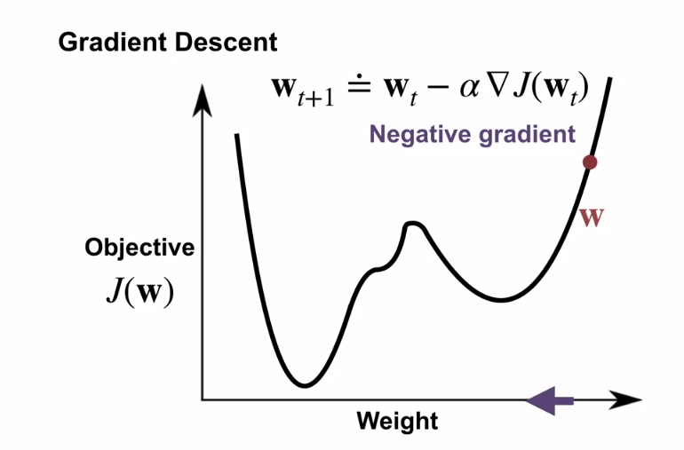
374. If we want to decrease our objective function, we should move the weights in the direction of the negative of the gradient. This is the idea of gradient descent. Here's the gradient descent update rule that captures this intuition. We make small changes in the direction that will most reduce the objective. We use a step size parameter, alpha, to control how far we move, as otherwise there is a risk of stepping too far. This is because moving in this direction is only guaranteed to decrease the objective locally. By doing such updates repeatedly with a sufficiently small alpha, we will eventually converge to a stationary point where the gradient is 0. Likely, this will be a local minimum. This means these weights are better than all weights in the immediate vicinity, but may not be the best possible. Other possible stationary points are local maxima and saddle points. These are unstable solutions the stochasticity inherent in our algorithms is usually enough to prevent getting stuck at these poor stationary points.
375. .
376. .
377. .
378. . 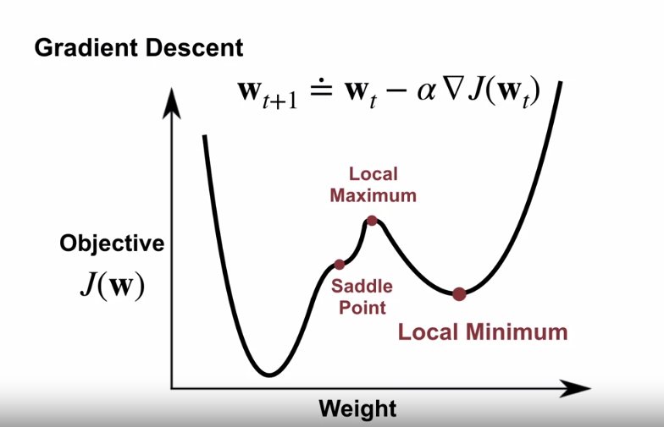
379. .
380. On the other hand a local minima is stable, so even a stochastic algorithm will tend to converge there. For this reason we usually talk about our algorithms converging to local minima. In some cases, gradient descent is guaranteed to converge to the global minimum, which is the best possible setting of the weights for the objective.
381. 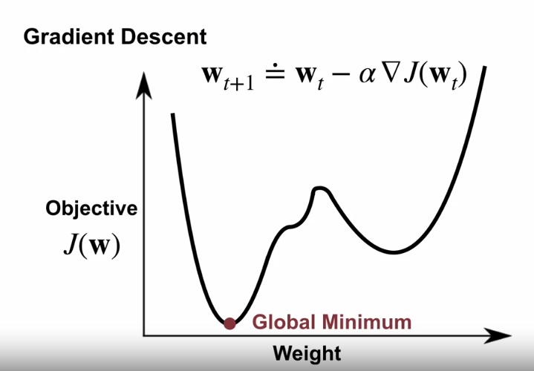
382. For example, this is true for the mean squared value error with linear function approximation. For more complex function approximate errors such as a neural network, a stationary point may not be a global minimum.
383. .
384. .
385. Note that a global minimum does not necessarily correspond to the true value function.
386. .
387. . 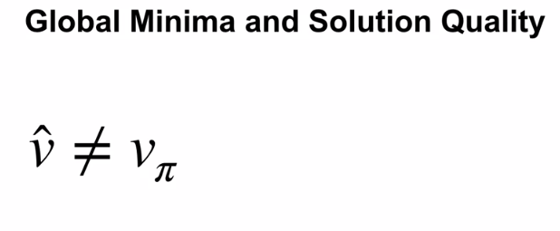
388. It is limited by our choice of function parameterization, and depends on our choice of objective. Imagine a feature vector which just contains a single element that is always one, no matter what state you are in. The approximate value function that minimizes mean squared value error, will converge to the average value over all the states.
389. .
390. .
391. .
392. 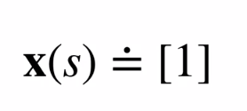
393. .
394. This is not a very good value function. However, this is still the best we can do under that parameterization in terms of the value error objective. That's it for this video. You should now understand how gradient descent can be used to find stationary points of objectives, and that these solutions are not always globally optimal. Next time we'll talk about how to use gradient descent specifically for our error. See you then.
395. .
396. .
397. .
398. . 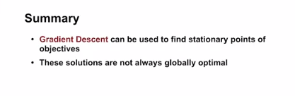
399. .
400. .
401. .
402. .
403. .
404. You now know one strategy to minimize objectives, gradient descent, and we formulated a clear objective for policy evaluation, the value error. We should now be able to put these together to approximate values.
405. Let's return to our old friend, Monte Carlo, and see how it can be used to minimize the value error.
406. After watching this video, you will be able to understand how to use gradient descent and stochastic gradient descent to minimize value error and outline the Gradient Monte Carlo algorithm for value estimation.
407. We just saw how to use gradient descent to minimize objectives.
408. To use this approach, the first step is to find the gradient of your objective. So let's start by computing the gradient of the mean squared value error, with respect to the weights of our approximation.
409. .
410. .
411. . 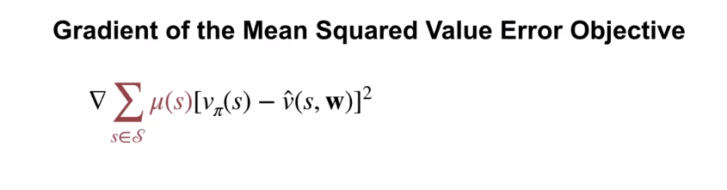
412. Remember, this objective is a weighted sum of the squared error over all states. Following the rules of calculus, we can pull the gradient inside the sum.
413. We then take the gradient of each term inside the sum, which requires the chain rule. The gradient of v_Pi minus v hat, equals the gradient of v hat because v_Pi is not a function of w.
414. In other words, changing w does not change v_Pi of s. The gradient of the value function approximation will depend on the particular parameterized function we are using.
415. .
416. .
417. . 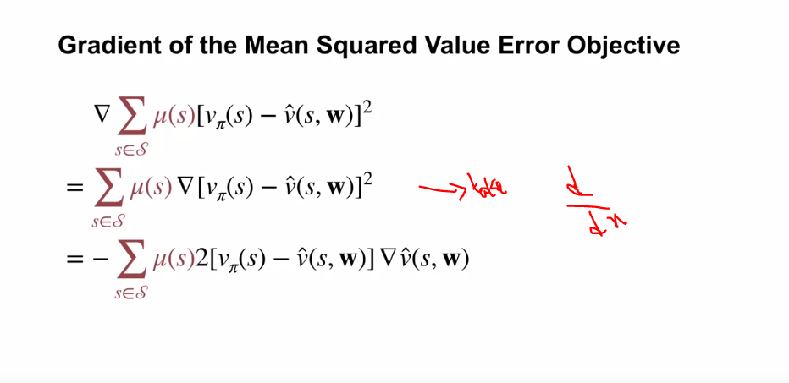
418. .
419. In the case of linear function approximation, the gradient is particularly easy to compute as we showed in the previous video. It is simply the feature vector in that state. This gradient makes sense.
420. The gradient of the value function approximation indicates how to change the weights to increase the value for that state.
421. We multiply this direction by the difference between the true value and our estimate. If the difference is positive, it means the true value is higher than our estimate, so we should change the weights in the direction that increases our estimate.
422. If the current error is negative, we should change the weights in the opposite direction. Computing the gradient for the mean squared value error requires summing over all states. This is generally not feasible. Also, we likely do not know the distribution Mu.
423. .
424. .
425. . 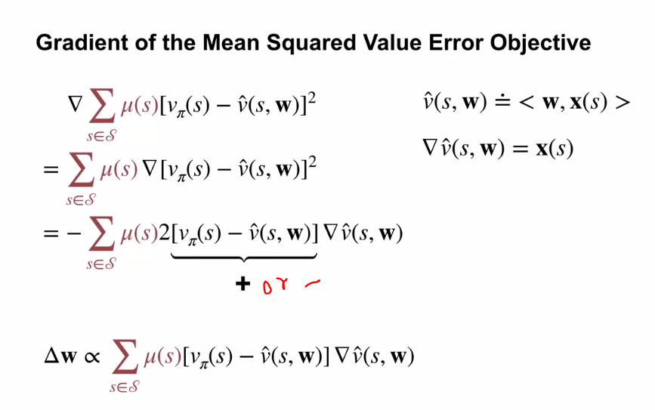
426. Instead, let's approximate this gradient. Imagine an idealized setting where we have access to v_Pi. Though we do not explicitly have Mu, we can sample states from it simply by following the policy.
427. .
428. .
429. . 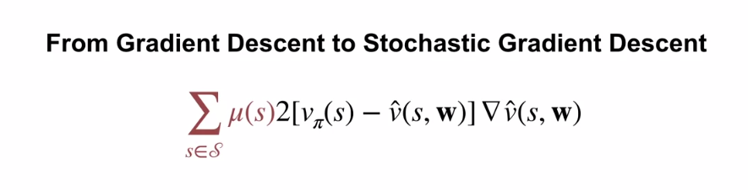
430. .
431. Step1: Let's take one of these states, S_1, that occurs while following the policy with target v_Pi of S_1. We can use this pair to make an update to decrease the error on that example.
432. . 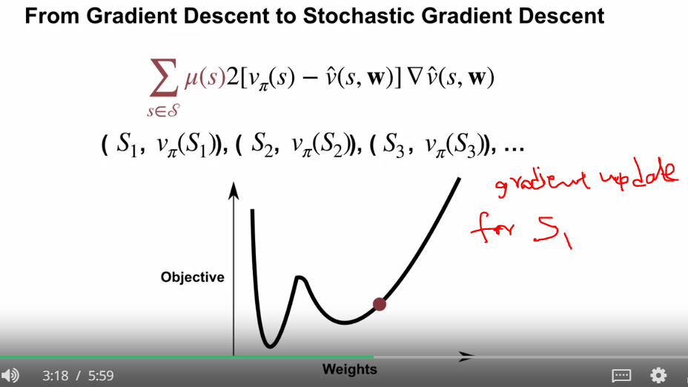
433. .
434. Here is the gradient for a single state. We can do gradient descent with this gradient to decrease the error on that state. So here's the corresponding gradient update rule for S_1.
435. .
436. .
437. . 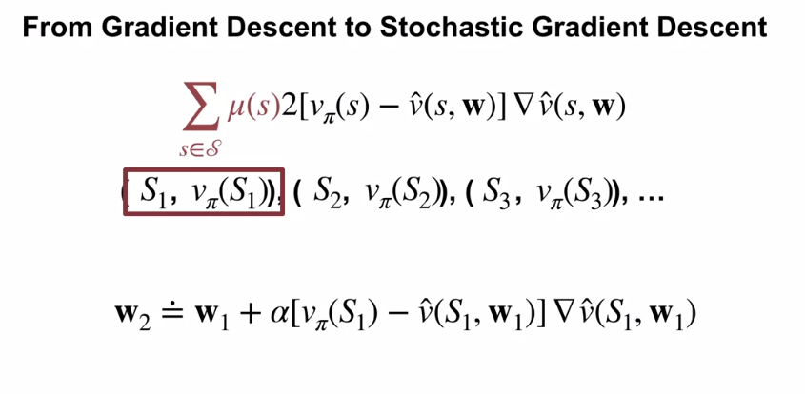
438. Step2:We can perform this update to decrease the error for this pair. Then we can do this again with another state, S_2, observed while following Pi.
439. .
440. .
441. . 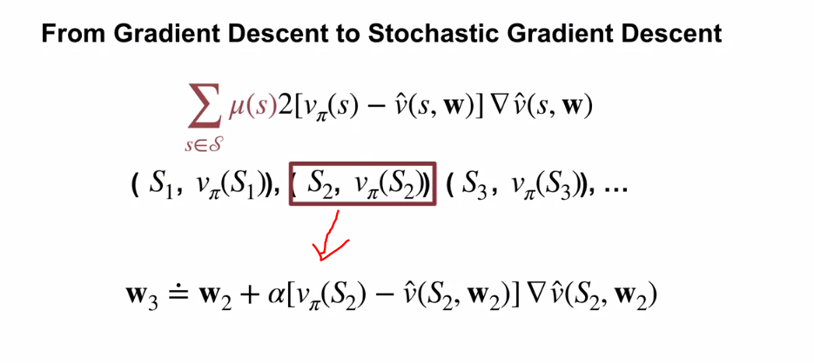
442. .
443. 
444. .
445. By making small updates in the direction that improves error on each pair, we might sometimes increase the error on the full objective.
446. But the overall trend will be to make progress for the full objective. This updating approach is called stochastic gradient descent, because it only uses a stochastic estimate of the gradient(update for each step).
447. .
448. .
449. In fact, the expectation of each stochastic gradient equals the gradient of the objective.
450. .
451. You can think of this stochastic gradient as a noisy approximation to the gradient that is much cheaper to compute, but can nonetheless make steady progress to a minimum.
452. .
454. Stochastic gradient descent allowed us to efficiently update the weights on every step by sampling the gradient. However, there is one remaining practical issue. We do not have access to v_Pi.
455. .
456. Let's see how we can get rid of it from our update rule. Let's replace v_Pi with an estimate.
457. .
458. .
459. . 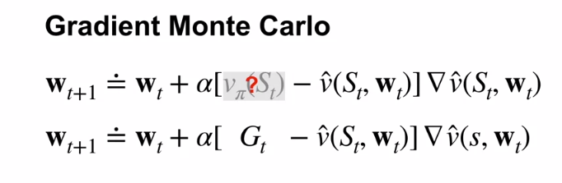
460. .
461. One option is to use samples of the return for each visited state, S_t, as we did for Monte Carlo methods. This makes sense because the value function is the expected value of these samples.
462. .
463. .
464. In fact, the expectation of the gradient when we use a sampled return in place of the true value, is still equal to the gradient of the mean squared value error. This brings us to the Gradient Monte Carlo algorithm for estimating v_Pi.
465. .
466. .
467. 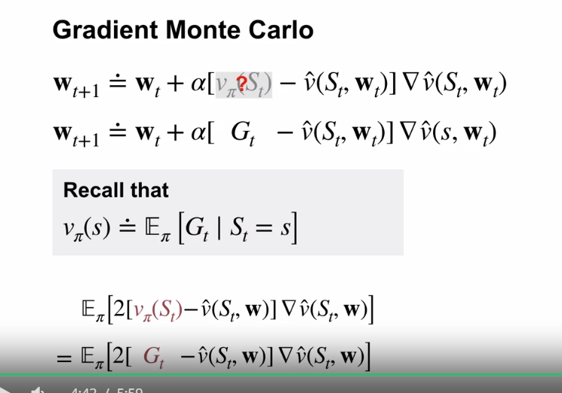
468. .
469. .
470. .
471. .
472. .
473. 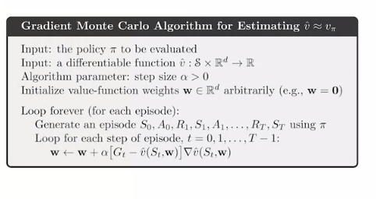
474. We take any policy Pi we wish to evaluate, we choose some function which maps states and weights to a real number that is differentiable in the weights. For a given weight vector, this v hat is a function of state producing the approximate values.
475. We choose a value of the step size Alpha, and initialize the weights parameterizing our estimate however we like. For example, to zero. On each iteration, the agent interacts with the environment to generate a full episode.
476. .
477. We compute the sampled return for each visited state. Then we loop through every step in the episode and perform a stochastic gradients and update based on the sampled returns.
478. .
479. That's it for this video. You should now understand how stochastic gradient descent can be used to estimate a value function, and how the Gradient Monte Carlo algorithm works. Next time, you'll get to see the algorithm in action.
480. .
481. 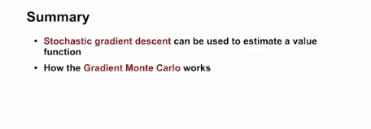
482. .
483. .
484. .
485. .
486. In this video, we will discuss a concrete example of value approximation using a technique called state aggregation.
487. We will use Monte Carlo with state aggregation to approximate the values for a large random walk domain.
488. .
489. 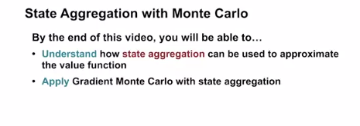
490. After watching this video, you will be able to understand how state aggregation can be used to approximate the value function and apply gradient Monte Carlo with state aggregation.
491. Let's look at an example where function approximation can help speed up learning, a large random walk task. The states are numbered from 1 to 1,000 and arranged in a line from left to right.
492. All episodes will begin in the middle of the line, at state 500. There are two actions, left and right. The left action moves the agent to the left, but not necessarily just one place.
493. .
494. .
495. . 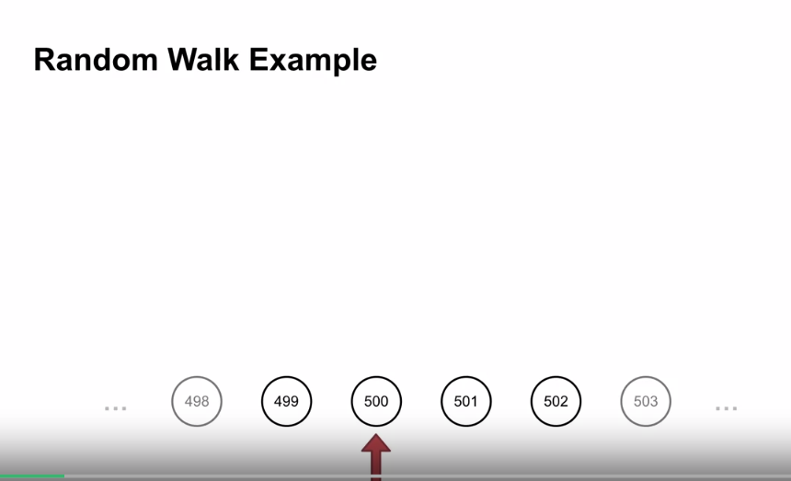
496. The agent jumps left to any state within 100 neighboring states, uniformly at random. Likewise, the right action jumps to the right, to one of the neighboring 100 states.
497. .
498. . 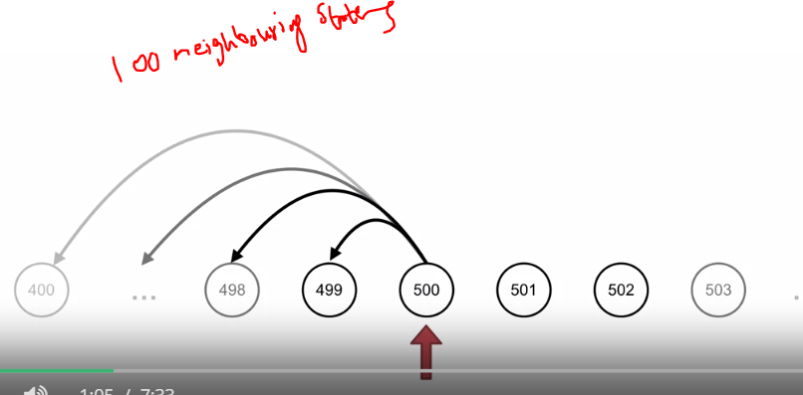
499. .
500. Let's evaluate the uniform random policy, which moves either left or right with equal probability. States close to the terminal state, on the left, have fewer than 100 neighbors to the left.
501. 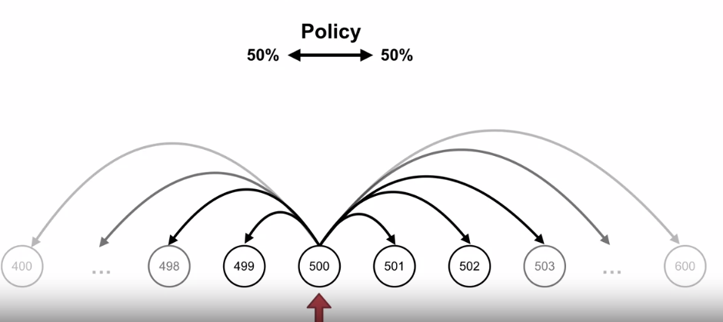
502. .
503. All actions that would jump past the end of the chain go to the terminal state instead. Likewise on the right. Terminating on the left gives a reward of minus 1, terminating the right gives a reward of plus 1.
504. .
505. .
506. . 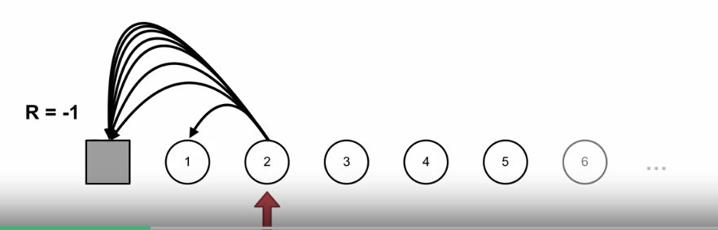
507. .
508. .
509. 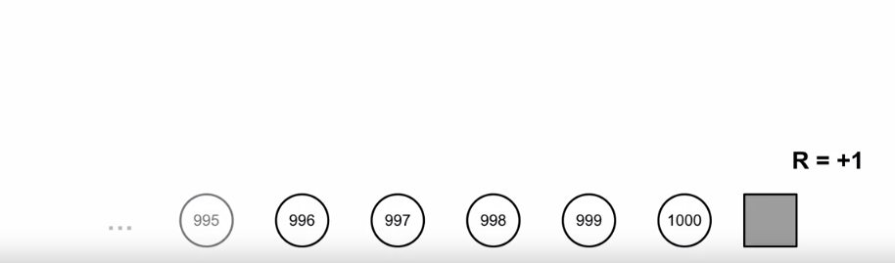
510. .
511. All other transitions give reward of 0. The discount gamma is 1. This task seems fairly simple, but learning the values for 1,000 states might take a lot of time.
512. .
513. .
514. .
515. . 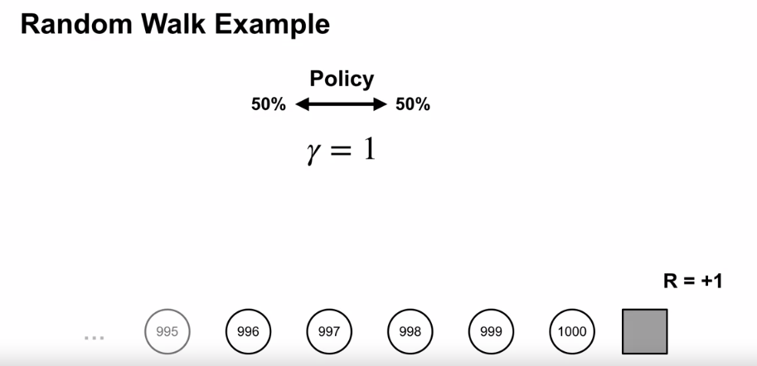
516. We might benefit from some kind of function approximation.
517. .
518. .
519. Here we will use a technique called state aggregation. As the name suggests, state aggregation treats certain states as the same.
520. .
521. . 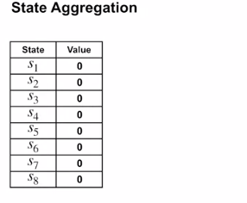
522. .
523. In this table of eight states, we might choose to aggregate states together in groups of four. So now instead of a table of eight entries for the value function, we just have two.
524. .
525. . 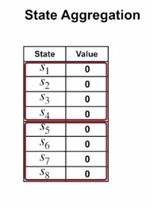
526. .
527. When we update the value of any state in the first group, the values of all the other states in that group is updated.
528. .
529. .
530. . 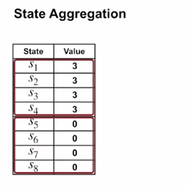
531. .
532. State aggregation is another example of linear function approximation. There is one feature for each group of states.
533. .
534. .
535. . 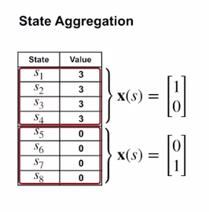
536. .
537. Each feature will be 1 if the current state belongs to the associated group, and 0 otherwise. The approximate value of a state is the weight associated with the group that state belongs to.
538. .
539. .
540. .
541. Let's look at the gradient Monte Carlo algorithm with state aggregation.
542. .
543. . 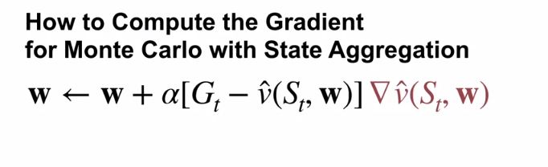
544. .
545. We already know how to compute the value for a given state. Now we need to think about how we compute the gradient of the value function so that we can use our key update formula.
546. .
547. State aggregation is an example of linear function approximation, so the gradient is equal to the feature vector.
548. .
549. .
550. .
551. ..
552. .
553. . 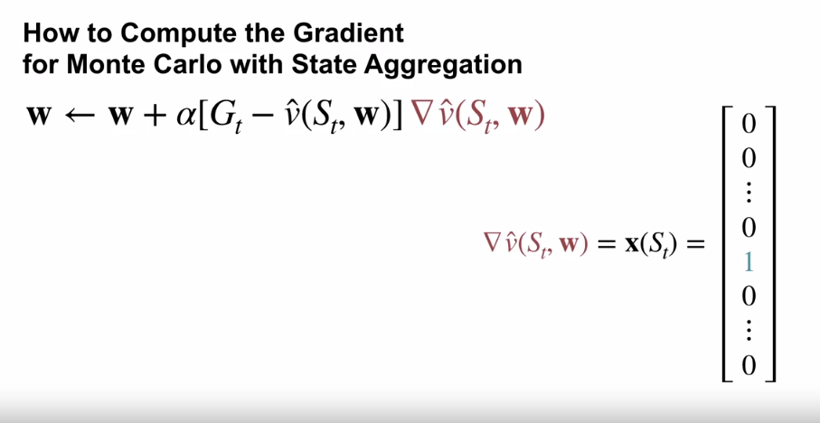
554. .
555. ..
556. .
557. The update rule modifies only the weight corresponding to the current active group.
558. .
559. .
560. .
561. . 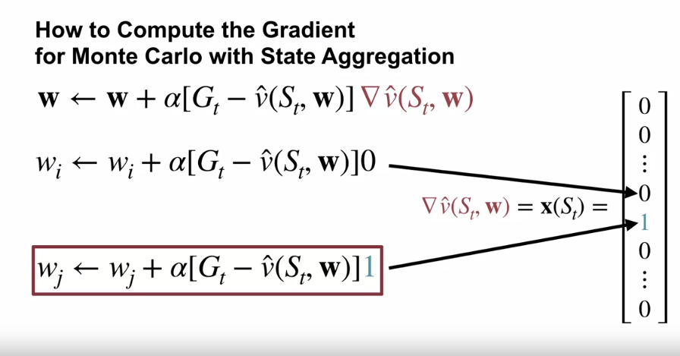
562. .
563. Let's think about how this update rule changes the weight. If the estimated value was smaller than the sample of return Gt, then the weight is increased.
564. .
565. .
566. If the estimated value was greater than the sample of return Gt, then the weight is decreased.
567. .
568. .
569. .
570. Let's return to the random walk and see how we can apply state aggregation. First, we have to choose how we aggregate states. State aggregation forces states in the same group to use the same value estimate. So ideally, we should group states together if we have reason to believe their values will be similar.
571. .
572. .
573. . 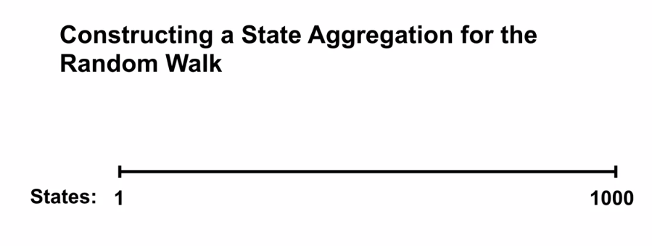
574. .
575. In this problem, it's an easy choice, states close together should have similar values.
576. .
577. . 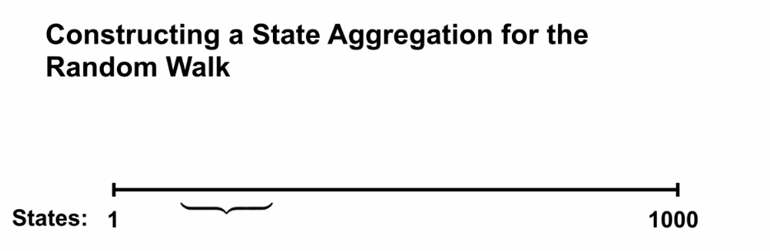
578. .
579. .
580. Now we have to choose how many states to put in each group. If the groups are small, our value estimates will ultimately be more accurate, but we'll take longer to learn.
581. .
582. .
583. We use ten groups, each containing 100 states. This is a nice change from 1,000 states we started with. [SOUND] Let's step through the gradient Monte Carlo algorithm to see how it works. We input the policy, our chosen state aggregation function, and a small step-size parameter value. We initialize the weights to 0.
584. .
585. .
586. . 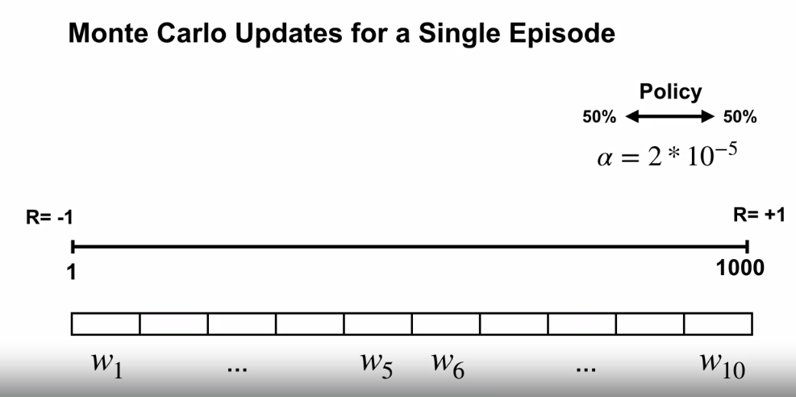
587. .
588. First, we generate an episode. Once we have a complete trajectory, we step through all the states we visited and make an update. The return from each state was 1, because the agent terminated on the right with a reward of plus 1. All other transitions generated 0 reward.
589. .
590. .
591. . 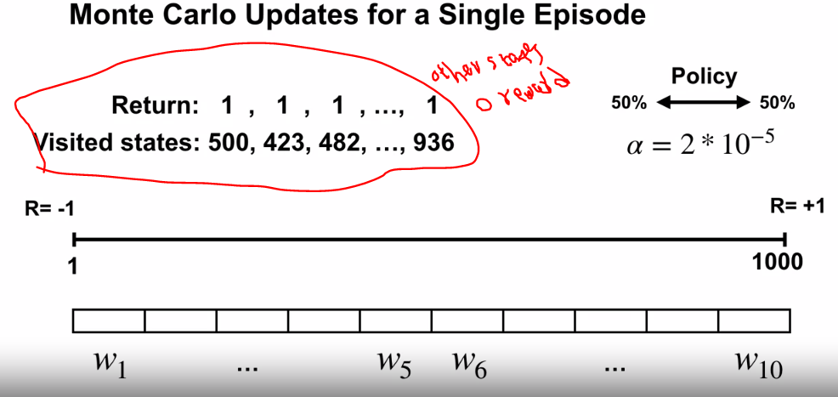
592. .
593. .
594. Our first update is to state 500, which belongs to group five. So we perform a gradient Monte Carlo update to that weight based on the sample return of 1.
595. .
596. .
597. .
598. 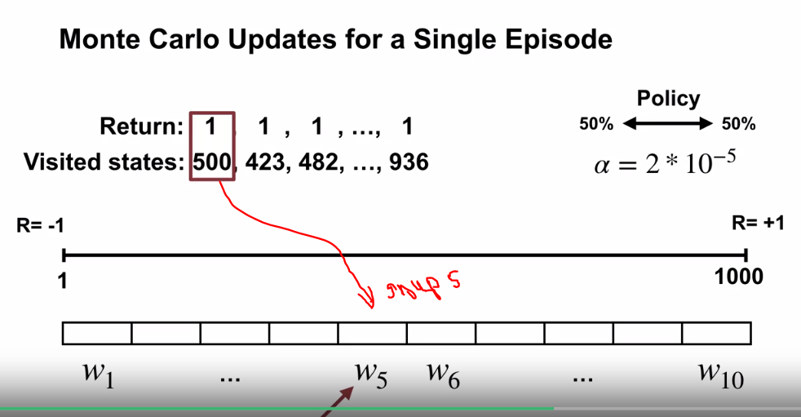
599. .
600. .
601. We do updates like this for every state in the trajectory. Eventually, we finish with state 936, which was the last state we visited before terminating. Since state 936 belongs to group ten, the last update we make is to weight 10.
602. .
603. After all the updates have been made, our value estimates might look something like this.
604. .
605. .
606. . 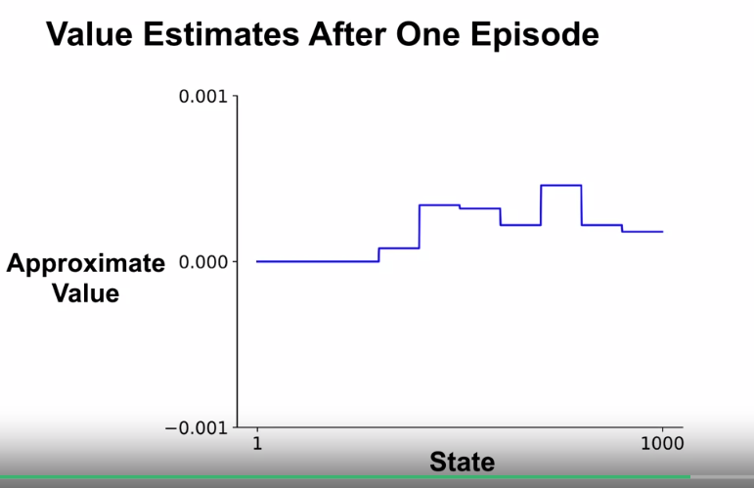
607. .
608. This plot shows the estimates after a single episode. We plotted the learn values for each states from 1 to 1,000. The state space is not continuous, but it makes sense to plot the approximate value as a line. Notice that the value estimates for each group are non-negative.
609. .
610. This is because the return for the first episode was positive and our initial estimates were 0.
611. .
612. Let's look at the same plot after another episode. This time the agent terminated on the left, getting reward of minus 1. That means the return from every state was minus 1. The weights for the visited states decreased slightly.
613. .
614. .
615. .
616. . 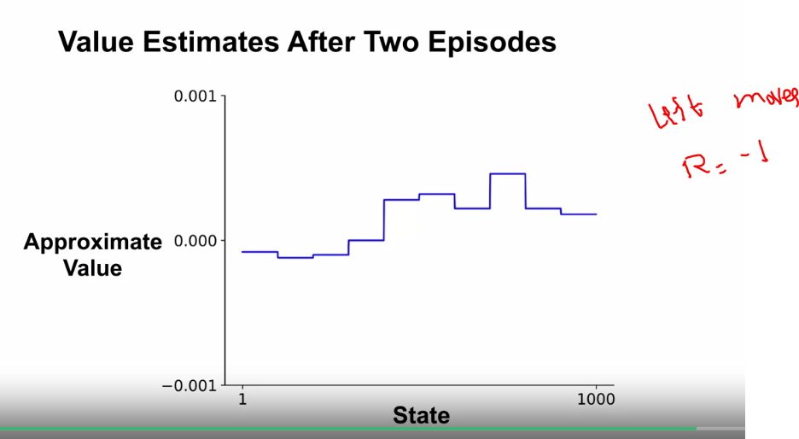
617. .
618. .
619. After running for many episodes, we get state values that look something like this. Each step in the plot corresponds to our group of states that share the same approximate value.
620. .
621. . 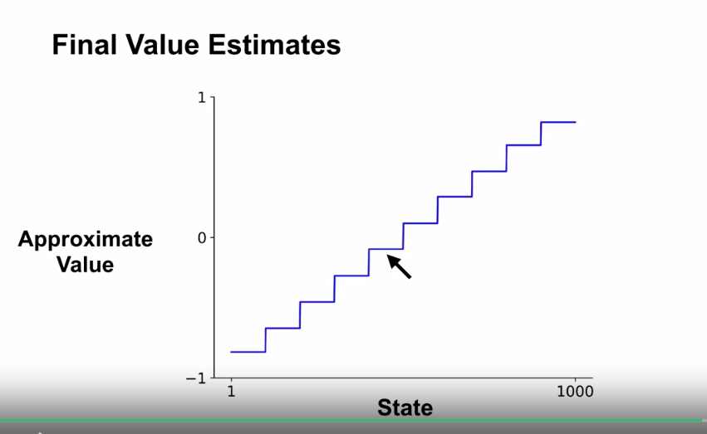
622. .
623. .
624. For comparison, here's the true value function. Although we have heavily approximated by aggregating many states together, our value estimate is not that far off.
625. .
626. .
627. .
628. . 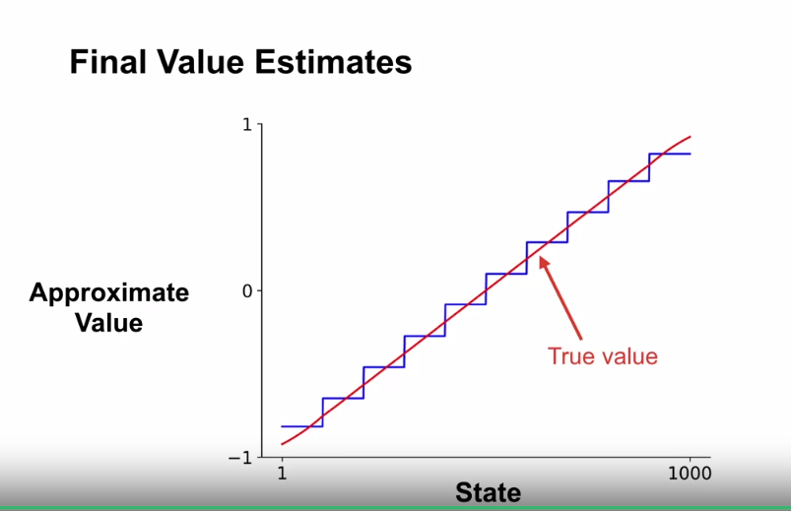
629. .
630. .
631. Why doesn't the red line pass directly through the center of all the blue steps?
632. .
633. .
634. .
635. .
636. This is where mu plays an important role. Recall mu of s is the visitation frequency for state s.
637. .
638. .
639. . 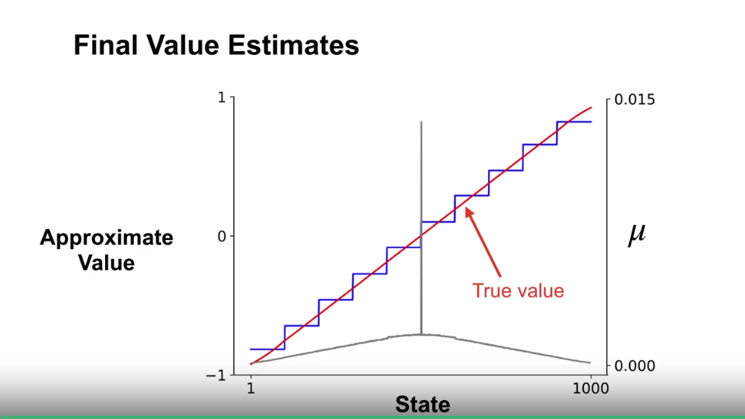
640. .
641. .
642. States near the center of the chain are visited more often than those near the terminal states, as depicted here.
643. .
644. For example, let's look at the leftmost group of states, states 1 to 100. States near state 100 are visited much more than states near state 1.
645. .
646. . 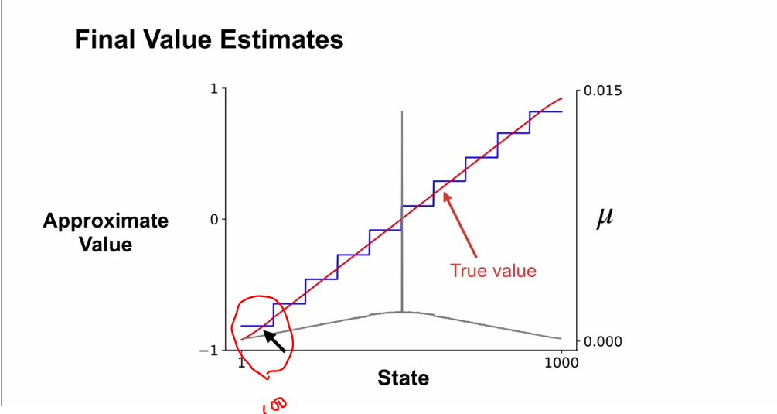
647. .
648. The approximate value is skewed towards the true value for states near state 100. This is because mu weights these states higher in the value error. [SOUND] That's it for this video. You should now have an idea of how gradient Monte Carlo works in practice when combined with state aggregation. See you next time.
649. .
650. .
651. .
652. .
653. .
654. .
655. .
656. .
657. TD learning is built on the idea that the agent can use its own estimate of the value function to update its predictions. We've seen TD learning in the tabular case. Today we will describe how it works with function approximation.
658. .
659. 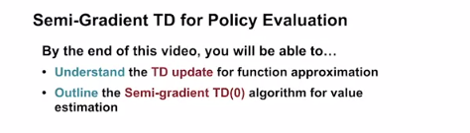
660. .
661. By the end of this video you will be able to understand the TD update for function approximation, and outline the semi-gradient TD algorithm for value estimation.
662. Recall the gradient Monte Carlo update equation. It updates our current value estimate to be closer to a sample of the return Gt, but we can consider using other targets instead of the return. In fact, we can replace the return in this update with any estimate of the value.
663. .
664. . 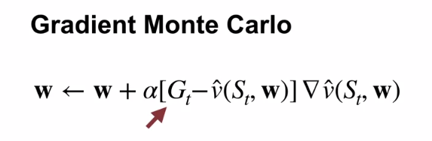
665. .
666. Let's call this estimate Ut. If Ut is an unbiased estimate of the true value then our function approximator will converge to a local optimum under the appropriate conditions.
667. .
668. 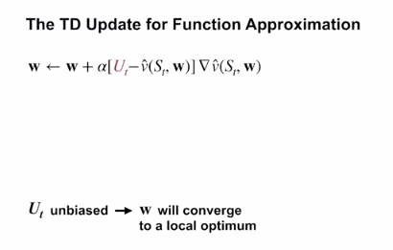
669. .
670. .
671. This was the case for the return, but we can also replace Ut with a bootstrap target, such as the one step TD target.
672. .
673. .
674. . 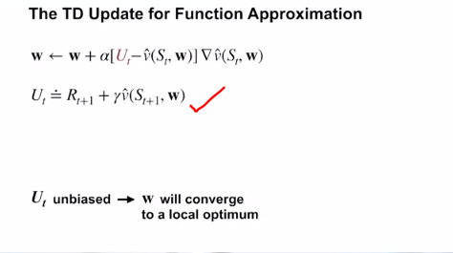
675. .
676. This is still an estimate of the return, but in this case, the estimate is biased. The TD target uses our current value estimate, which will likely not equal the true value function.
677. Because of this we cannot guarantee this algorithm will converge to a local minimum of the value error.
678. .
679. .
680. .
681. The upside is that the TD target often has lower variance than the sample of the return.
682. .
683. .
684. .
685. This means TD will tend to converge in fewer updates.
686. .
687. .
688. .
689. The TD update is not actually a stochastic gradient descent update. To see why we take the gradient of the error with respect to the weights for one sample.
690. .
691. .
692. . 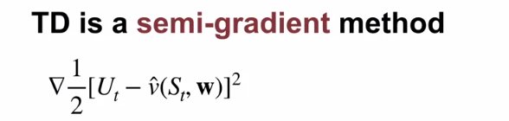
693. .
694. Remember Ut is equal to the TD target. Using the chain rule we get this expanded expression for the gradient of the squared error for one sample.
695. .
696. . 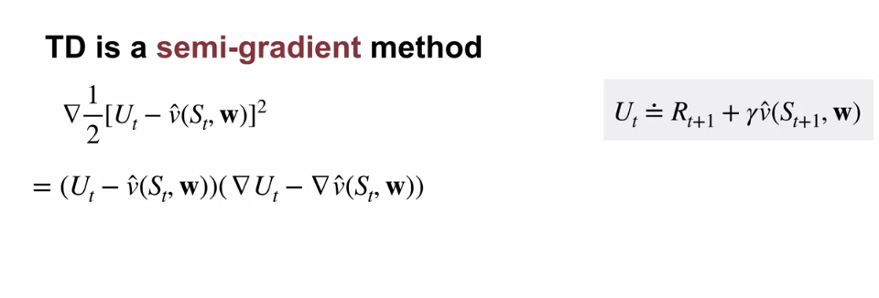
697. .
698. .
699. But, wait a minute. This doesn't look like the TD update.
700. .
701. .
702. .
703. .
704. .
705. These two expressions would only be equal if the gradient of Ut=0.
706. .
707. . 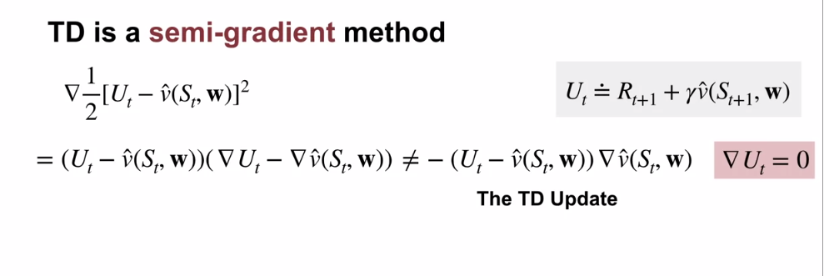
708. .
709. .
710. This is not the case for TD. In TD the target contains an estimate of the value, which depends on the weights. This means the gradient of Ut is not 0 as shown here,
711. .
712. .
713. .
714. . 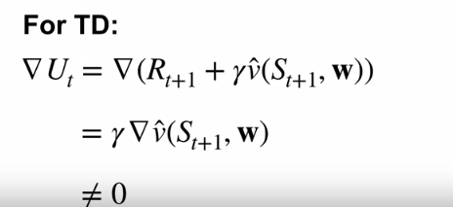
715. therefore TD is not performing gradient descent updates on the squared error. We call it a semi-gradient method.
716. .
717. .
718. Despite this, TD converges in many of the cases we care about. We will discuss TD's convergence properties in an upcoming video. Here is the pseudocode for semi-gradient TD. It's actually very similar to the TD argument for the tabular setting. This album does not have to wait until the end of an episode to make updates. TD performs an update on each step, unlike radio Monte Carlo. On each step of the episode the agents selects an action A, in state S. We use the resulting reward in next state to compute
719. the TD target, and update the weights immediately. We continue in this way until we reach the terminal state, which is defined to have value zero, then we start a new episode, and that's it.
720. .
721. . 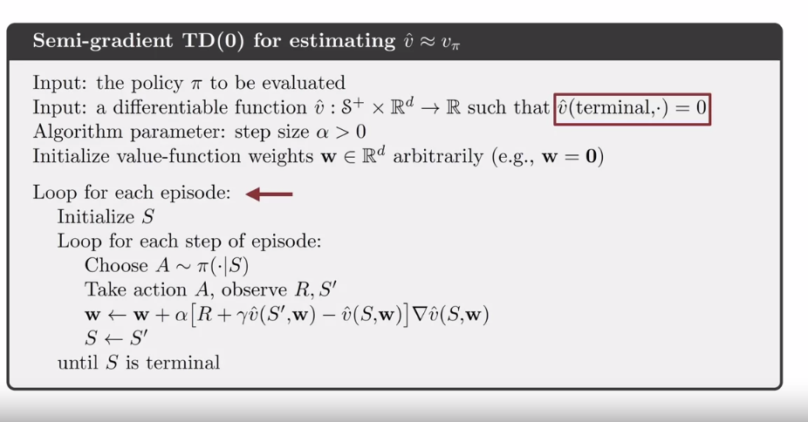
722. .
723. . 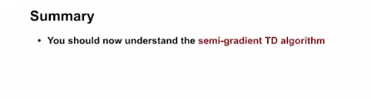
724. It's really not that different from tabular TD
725. That's it for today.
726. You should now understand the semi-gradient TD algorithm.
727. .
728. .
729. .
730. ..
731. .
732. ..
733. .
734. We just talked about Monte Carlo with function approximation and TD with function approximation. But how do these algorithms differ?
735. . 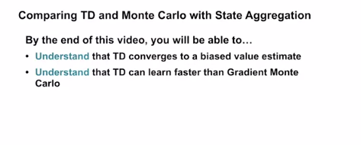
736. Today, we're going to talk more about the bias in the TD update and compare it to Monte Carlo in a small experiment.
737. .
738. After watching this video, you'll be able to; understand that TD converges to a bias value estimate and understand that TD can learn faster than Gradient Monte Carlo.
739. .
740. Under reasonable assumptions, Gradient Monte Carlo will approach a local minimum of the Mean Squared Value Error with more and more samples.
741. ..
742. .
743. .
744. . 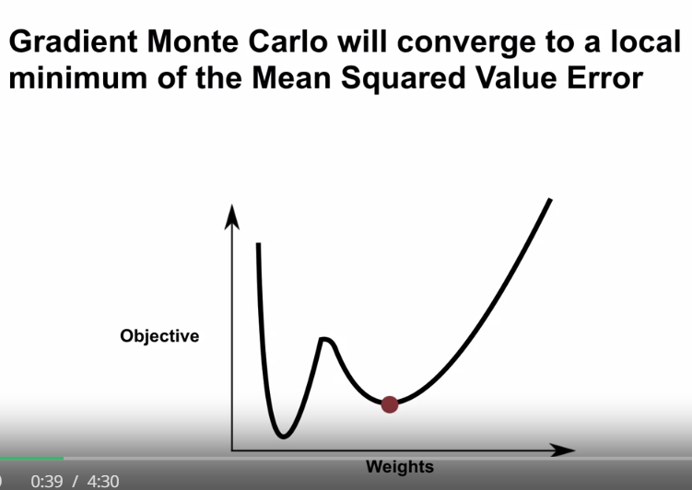
745. .
746. .
747. ..
748. . This is because it uses an unbiased estimate of the gradient of the value error. See below
749. . 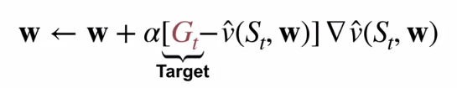
750. .
751. .
752. In theory, we need to run the algorithm for a very long time and decay the step size parameters to obtain this convergence. In practice, we use a constant step size. So the algorithm oscillates around a local minimum.
753. On the other hand, the TD target depends on our estimate of the value in the next state.
754. .
755. . 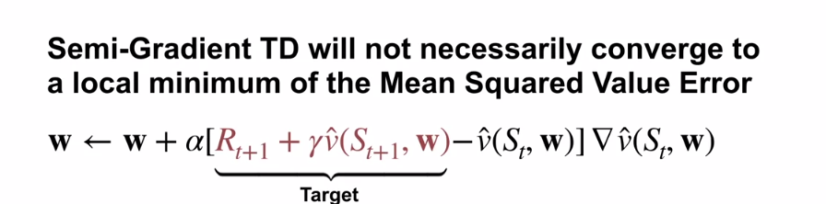
756. ..
757. This means our update could be biased because the estimate in our target may not be accurate. Since our value approximation will never be perfect even in the limit, the target may remain biased.
758. .
759. We cannot guarantee that semi-gradient TD will converge to a local minimum at the Mean Squared value error. Of course, this bias will reduce as their estimates improved.
760. .
761. .
762. .
763. . 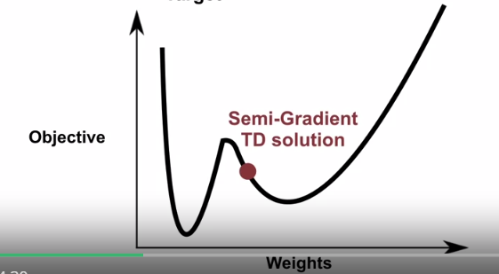
764. .
765. But how do all these theoretical concerns impact performance in practice?
766. .
767. Let's return to the 1,000 state Random Walk example, to see the impact of bias in the TD update. This time, we'll learn approximate values using semi-gradient TD instead of Monte Carlo.
768. .
769. .
770. .
771. . 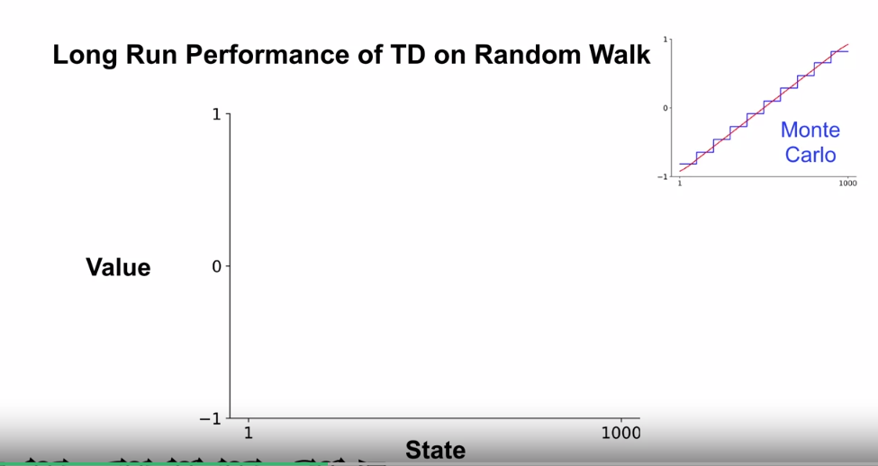
772. .
773. After running TD for a long time, such that our value estimates have stopped changing, this is what we get.
774. .
775. The value estimates do not align well with the true values for many states.
776. .
777. ..
778. . 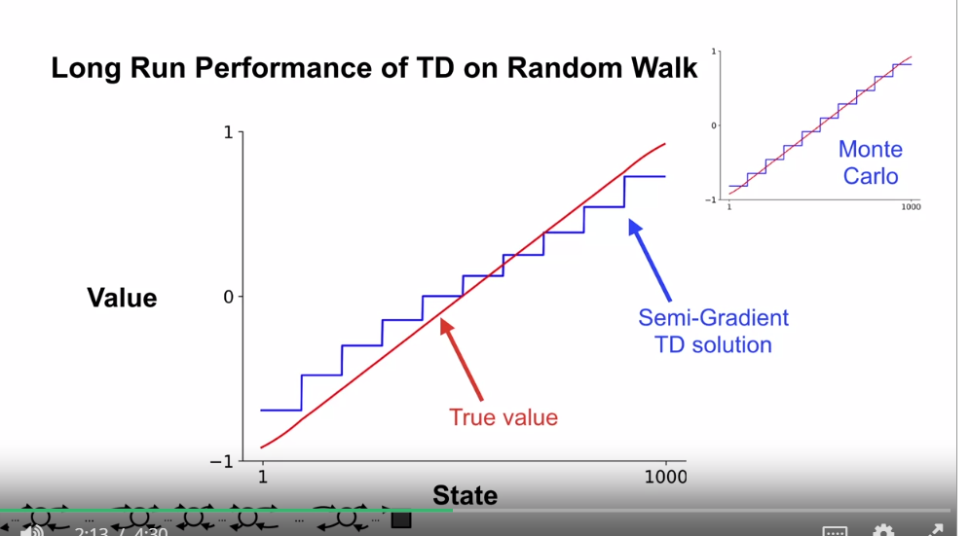
779. .
780. .
781. TD's estimates are not as accurate as the estimates done by Monte Carlo.
782. .
783. In this domain, the state aggregation, Monte Carlo has an advantage in terms of long-run performance.
784. .
785. But what about the speed of learning?
786. Which of TD and Monte Carlo makes best use of limited samples?
787. Let's run a different experiment to get to the bottom of this. To focus on early learning, we only run 30 episodes.
788. .
789. . 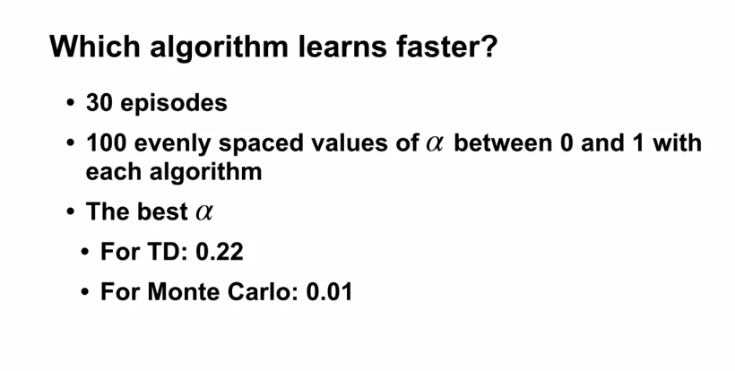
790. Remember, in the last experiment, we used 1,000 episodes. The performance of both algorithms depends on how we set the step size parameter Alpha.
791. The two algorithms may require very different values of Alpha. To do a fair comparison, we tested each algorithm with 100 evenly spaced values of Alpha between zero and one.
792. We take the best performing Alpha for each algorithm and compare the performance. The best Alpha was defined as the one that resulted in the lowest value error after 30 episodes of training.
793. For this task, the best Alpha we found for TD was 0.22. The best alpha for Monte Carlo was much smaller, 0.01.
794. Let's plot the performance of each algorithm. The y-axis shows the root mean squared value error for the 1,000 states averaged over 100 runs. The x-axis shows us the episode number.
795. .
796. . 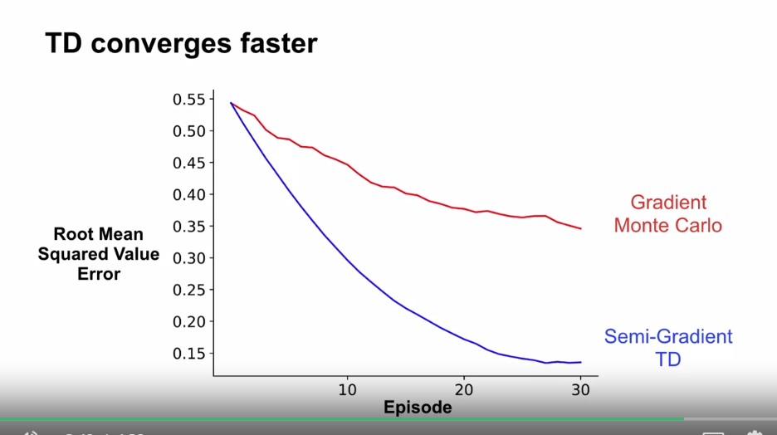
797. We expect a value error for each algorithm to start high and progressively decrease with more and more episodes. Let's look at the results.
798. .
799. We see the TD reaches a lower error faster. This is not a one-off result.
800. .
801. TD often learns faster the Monte Carlo.
802. This is because TD can learn during the episode and has lower variance updates.
803. .
804. Monte Carlo is better on long-run performance, it's not always the main concern. We can never run our experiments to achieve asymptotic performance. Early learning is perhaps more important in practice. That's it for today. You have now seen how the TD update for function approximation can be biased. But we often prefer TD learning over Monte Carlo anyway because it can learn more quickly. See you next time.
805. .
806. 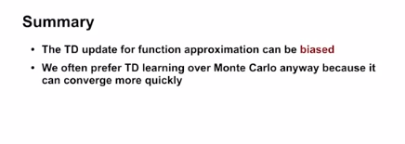
807. .
808. .
809. .
810. .
811. .
812. .Knowledge of Deep Mind
813. .
814. .
815. .
816. .
817. My name is Doina Precup. I'm a professor at McGill University and I also work DeepMind as a research scientist. A lot of my research interests have to do with abstraction in reinforcement learning.
818. .
819. .
820. ..
821. . 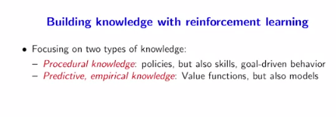
822. .
823. .
824. Reinforcement learning agents have to acquire two kinds of knowledge. One, is what we would call procedural knowledge, how to do things, and the policy is the most basic example of this. But actually, there's lots of other pieces of knowledge we might want to have, like how to interact with particular objects or how to travel between different places. So I will talk about this in terms of skills or options or sometimes goal-driven behavior.
825. .
826. We also would like to have predictive knowledge or empirical knowledge which means, what might happen conditioned on an agent's behavior? This is value functions but also other things like for example models.
827. .
828. Now, there is certain characteristics we would like to have for these kinds of pieces of knowledge. One is we would like this knowledge to be learnable, so that we can acquire it from data, we would also like it to be expressive.
829. .
830. . 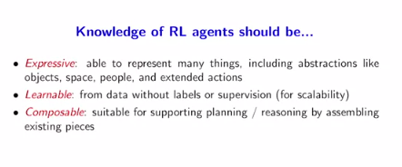
831. We would like for the agent to be able to know about many different things and different circumstances, and we would like the agent to be able to compose pieces of knowledge that it already has into larger pieces.
832. Those are the main things for our knowledge representation.
833. .
834. . 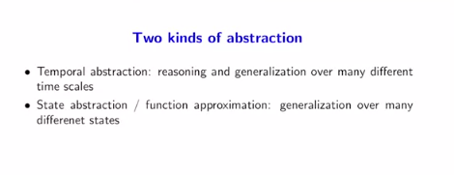
835. Knowledge representation has to generalize both in terms of the agent's behavior over time scales as well as in terms of the agents capacity to reason about the world about its perceptions.
836. So that's where state abstraction function approximation come in.
837. I will talk a little bit more about generalization in terms of procedural knowledge over the different timescales.
838. Now, why might we want to have something like this? Well, a lot of our agents when they are "born", they have a very limited set of actions and these actions always last one time step because we want to fit with the markup decision process framework.
839. But in realistic circumstances, agents might need to keep a course of action for many time steps.
840. For example, if you're thinking of going from Montreal to Edmonton, you don't want to think in terms of muscle twitches, you'd like to think in terms of taking a cab to the airport and then fly to Edmonton and taking a cab to the university and maybe grabbing dinner in the meantime.
841. These are periods of time that are extended, they are not the same. But the agent should be able to reason at this level because that means its plan will now be much shorter, only four steps instead of many thousands of steps potentially, and also the plan might be reusable in other circumstances.
842. For example, if we want to travel to Edmonton or to Toronto or some other city, the agent would still go through the same kinds of steps.
843. .
844. . 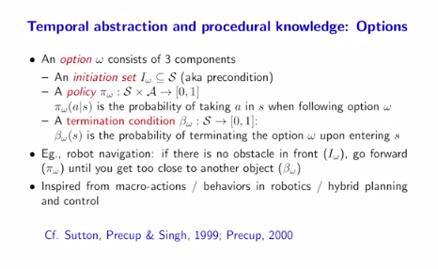
845. How do we formalize this idea of abstraction at the temporal level or at the behavioral level?
846. One way to do this is through this notion of options. We're going to think of an option as consisting of three components. One is an initiation set, that means the set of circumstances under which an option could be initiated.
847. For example, we can only fly somewhere if we are at the airport. So being at the airport is an initiation set.
848. .
849. A second component is an internal policy. That means, a way of picking preventive actions while the option is executing.
850. For example, if we're walking to the gate, the walking motion is a policy and that will take control and execute. This is the usual probability of taking preventive actions conditioned on the agent state.
851. Then, we have a termination condition. Typically, this is also stochastic. It basically tells us what is the probability of the agent finishing the behavior in any particular state. So if we're walking to the gate, we might finish this behavior because we've reached the gate of the airplane but we might also finish the behavior. For example, if there is an alarm, maybe we want to go outside the building, so switch the behavior to something else.
852. .
853. . 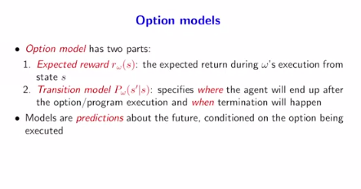
854. If we think in terms of these components, actually agents have now transient behavior that they can execute and we can also think of models that are paired up with these chance of behavior.
855. Each option will have a model and its model consists of the expected reward that the injured might get along the way, and essentially a transition probability distribution of the states where it might end up.
856. Because options take different amounts of time, instead of just thinking of transitions to next states, we are in fact going to think of transition to a next time as well.
857. .
858. So this will be a joint distribution, in fact, over states and over times.
859. .
860. . 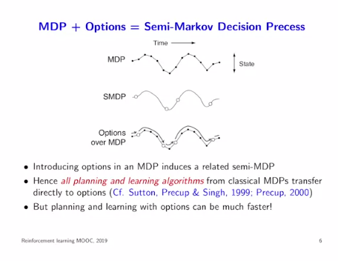
861. .
862. .
863. But once an agent is endowed with options, it essentially reasons in the same way that it would in MDP except we have what's now called the semi-Markov decision process.
864. The Markov property still holds but the duration of a behavior is not fixed, it's actually based on probability distribution.
865. However, all of the planning and learning algorithms that you already know and love such as valid duration, temporal difference learning, all the other things that are talked about in this course, work in almost the same way in semi-Markov decision processes as they do in MDPs.
866. So we can bring to bear all of the ideas from these algorithms in order to learn about options.
867. One of the interesting questions is how to do temporal abstraction at the same time as doing state obstruction or doing function approximation.
868. .
869. Ideally, we would like to do both of these things. So we would like to reason about the airport rather than specific centimeters in space just like we would like to think about the behavior of going to the airport instead of muscle twitches.
870. However, these two are actually distinct and we would like them to work together in some sense.
871. But how to get good temporal abstraction and state obstruction at the same time, and in a way in which they communicate well with each other is actually still an open research problem.
872. Similarly, one interesting open restricts problem is figuring out where options come from. So who tells us what is a good termination condition? Well, this is something that we would like to find out that we don't quite have a handle on it.
873. .
874. .
875. 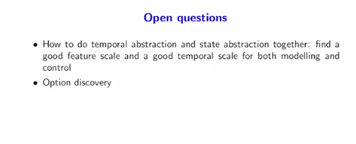
876. .
877. .
878. .
879. .
880. 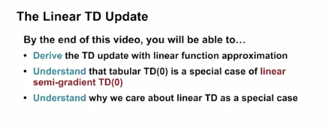
881. .
882. In principle, we can use any kind of function approximation for reinforcement learning.
883. Linear function approximation is an important special case. It is simple enough that we can understand it well, but it is still quite powerful in general. In fact, linear function approximation with TD has been used to build Atari agents that exceed human performance in many games. After watching this video, you'll be able to derive the TD update with linear function approximation, understand that tabular TD as a special case of linear semi gradient TD, and understand why we care about linear TD as a special case.
884. .
885. Recall the update for semi gradient TD. It adjusts the weights in the direction of the TD error times the gradient of the approximate value function with respect to the weights.
886. .
887. . 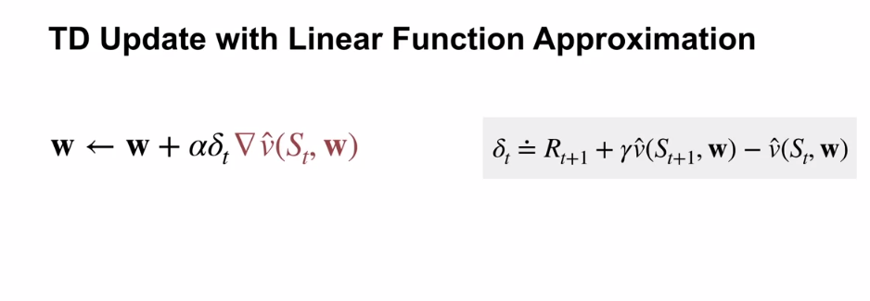
888. .
889. In the linear case, the gradient of the approximate value for a state is just the feature vector for that state.
890. .
891. . 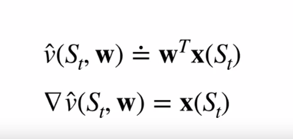
892. .
893. So the update for semi gradient TD would look like this. The weight is updated in the direction of the feature vector times the TD error.
894. .
895. . 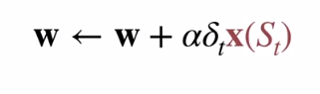
896. .
898. If a feature is large, then the corresponding weight can have a large impact on the prediction.
899. On the other hand if the feature is zero, then that weight has no impact on the prediction and the gradient is therefore zero.
900. .
901. The fixed basis given by the expert design features has a large impact on the update. If well-designed, we can get effective value function approximation with a simple update.
902. We already saw how linear value function approximation is a strict generalization of tabular value function approximation.
903. .
904. We can show that linear TD is a strict generalization of both tabular TD and TD with state aggregation.
905. .
906. Let's take a closer look at the algorithm to see this explicitly for tabular TD.
907. Imagine we have a tabular state representation. Only one feature will be equal to one corresponding to the current state and the rest will be zero.
908. .
909. . 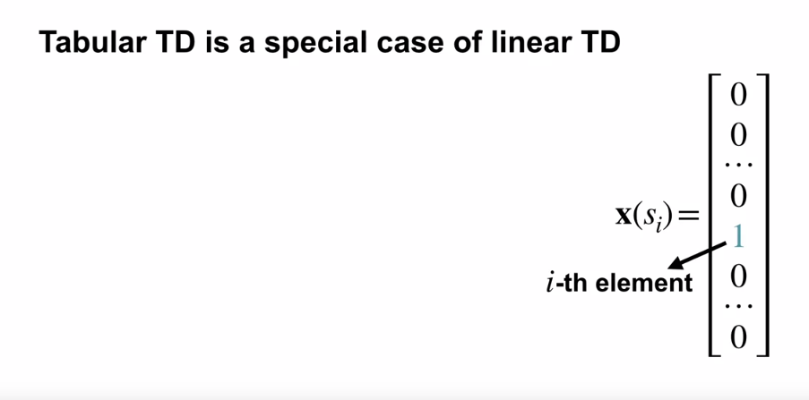
910. .
911. The value approximation for a state is equal to the weight associated with the current state.
912. .
913. . 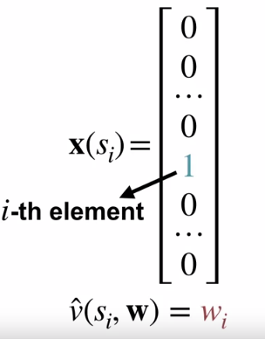
914. .
915. We can therefore think of the weight vector as just a table of values, one for each state.
916. .
917. 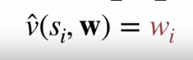
918. .
919. Here's the update for semi gradient TD with these tabular features.
920. .
921. . 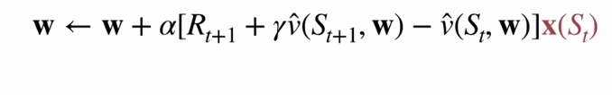
922. .
923. In the update, the feature vector X of ST selects a single weight associated with the current state.
924. .
925. . 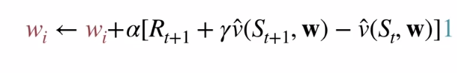
926. .
927. This weight is just the value estimate for the state.
928. So this update corresponds to the tabular TD update we saw in a previous course.
929. We can use the same analysis to show that TD with state aggregation is also a special case of linear TD.
930. .
931. But why do we care so much about the special case of linear function approximation?
932. .
933. Linear methods are simpler to understand and analyze mathematically.
934. Much of the theory of TD learning is for the linear setting. We will discuss this more in the next video.
935. In some applications, you may have access to expert knowledge to help you design good features. Perhaps, you are the domain expert or perhaps you can talk to someone who knows a lot about your application.
936. If we can design these features well, then we can expect linear methods to learn quickly and achieve good prediction accuracy.
937. Feature design provides one way to incorporate domain knowledge that can result in good performance in practice. That's it for today. We talked about the linear TD update, how tabular TD is a special case of linear semi gradient TD, and why linear function approximation might be useful. See you next time.
938. .
939. 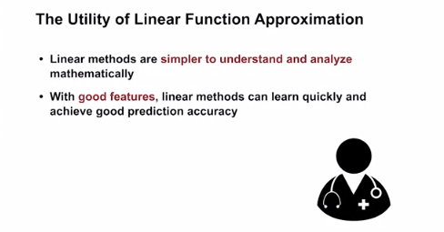
940. .
941. .
942. .
943. 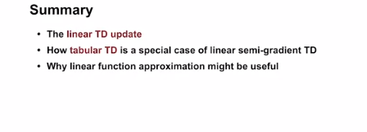
944. .
945. .
946. .
947. In a previous lecture, we introduced semi gradient TD as approximate gradient descent in the mean squared value error. But this is a simplification of a more nuanced story.
948. TD does not precisely optimize this objective, instead, there's a different objective we can consider for semi gradient TD with linear function approximation.
949. In fact, linear TD provably converges to a well understood approximation called the TD fixed point. We'll talk about this today.
950. .
951. By the end of this video, you will be able to understand the fixed point of linear TD and describe a theoretical guarantee on the mean squared value error at the TD fixed point.
952. Let's take a closer look at the TD update with linear function approximation.
953. The value of a state is the inner product of the state features and the learn weight vector.
954. . 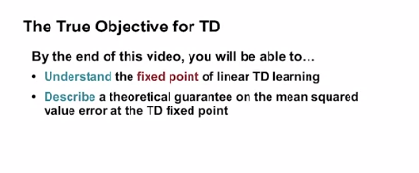
955. .
956. To simplify the notation, we'll use X_ t to mean the features associated with the state S_t.
957. We can then expand the TD update like this. We can rewrite this using a bit of linear algebra.
958. . 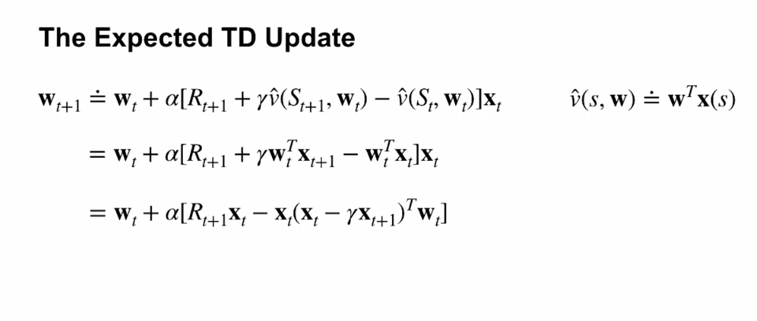
959. .
960. First, we'll pull X_t into the brackets. We then use the fact that taking the transpose of a scalar, leaves it unchanged.
961. Now, let's think about what this update looks like in expectation.
962. .
963. .
964. Understanding the expected update is key for proving convergence. The TD update can be rewritten as the expected update plus a noise term, and so is largely dominated by the behavior of the expected update.
965. The expected update characterizes the expected change in the weight from one time step to the next.
966. The expected TD update can be written as a vector b minus a matrix A times the current weights.
967. .
968. . 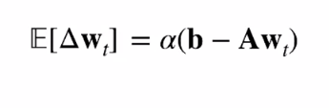
969. The matrix A is defined in terms of an expectation over the features, while the vector b is defined in terms of the features and the reward.
970. .
971. . 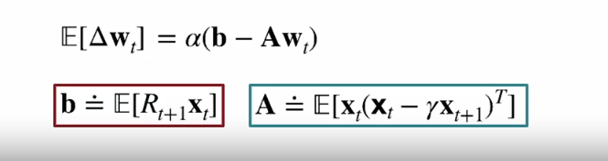
972. The weights are said to converge, when this expected TD update is zero.
973. .
974. . 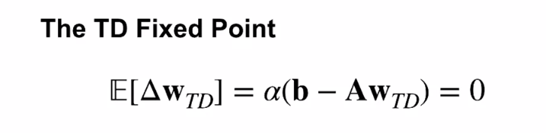
975. We call this point W_TD.
976. If A is invertible, we can express this as W_TD equals A inverse b. More generally, W_TD is a solution to this linear system.
977. . 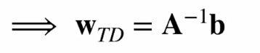
978. .
979. We call this solution the TD fixed point.
980. It can be proven that linear TD converges to this point. In fact, it can be shown that TD minimizes an objective that is based on this A and b.
981. This objective extends the connection between TD and Bellman equations, to the function approximation setting.
982. .
983. .
984. . 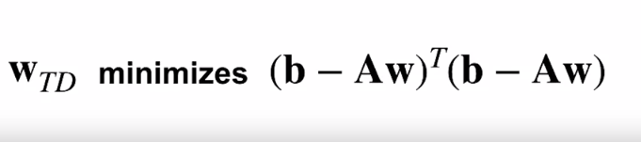
985. Recall that in the tabular setting, we describe TD as a sample based method for solving the Bellman equation. Linear TD similarly approximates the solution to the Bellman equation, minimizing what is called the projected Bellman error.
986. The details of this objective are beyond the scope of this course, but you can refer to the course textbook for more detail.
987. .
988. The key takeaway is that even though TD does not converge to the minimum of the mean squared value error, It does converge to the minimum of a principled objective, based on Bellman equations.
989. .
990. Nonetheless, we do still want to understand the relationship between the solution found by TD and the minimum value error solution.
991. .
992. We can formally characterize this relationship with this equation.
993. .
994. .
995. . 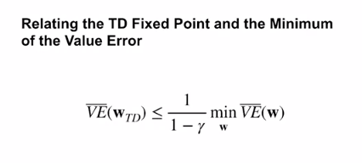
996. .
997. The difference between the TD fixed point and the minimum value error solution can be large if Gamma is close to one.
998. If Gamma is very close to zero on the other hand, the TD fixed point is very close to the minimum value error solution. This bound also depends on the quality of the features. If the features are limited, both the minimum mean squared value error and the value era, the TD fixed point, may be large.
999. If we can perfectly represent the value function, then regardless of Gamma, the TD fixed point is equivalent to the minimum value error solution. This is because both the left and right-hand sides would be zero.
1000. So in general, why isn't the TD fixed point equal to the minimum value error solution? This is because of bootstrapping under function approximation.
1001. If our estimate of the next state is persistently inaccurate due to function approximation, then TD forever update towards an inaccurate target.
1002. On the other hand, if our function approximator is very good, then our estimate of the next state will become very accurate.
1003. .
1004. So bootstrapping off this estimate is not problematic and the error for the TD Solution is close to the minimum value error. That's it for today. You should now know a bit more about why linear semi-gradient TD is guaranteed to converge to a fixed point called the TD fixed point, and how the TD fixed point relates to the minimum Mean Squared Value Error.
1005. .
1006. 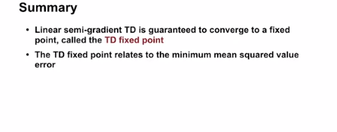
1007. .
1008. .
1009. This week, we learned a lot about how to extend reinforce learning for the tabular case to function approximation.
1010. In many real-world problems, it is not practical to enumerate every possible state in a table. So moving to function approximation is a big step in making reinforce learning more broadly applicable.
1011. . 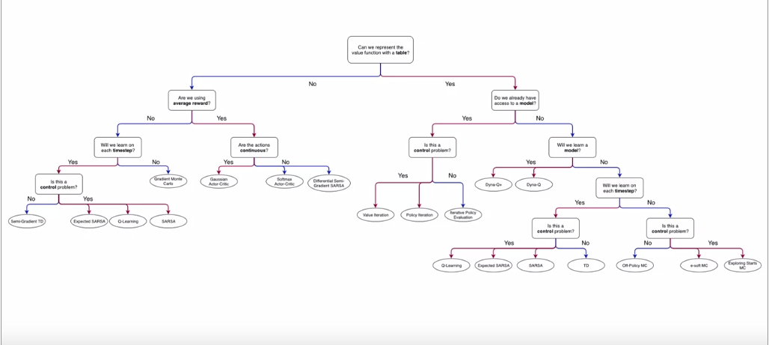
1012. In this video, we'll do a quick recap of what we've learned. We've covered a lot of material already, and it's easy to get lost in all the different concepts. Select step back and see how this week's topics fit into the bigger picture. This maps shows all the different algorithms we've covered in this specialization and how they relate to each other.
1013. Remember, the map only shows the items we present in the specialization. The main conceptual change this week was moving to the framework of parameterized function approximation.
1014. .
1015. This means, we are no longer using a table to store the value of each state. This puts us on the left side of the map.
1016. Our discussion of average reward will come later. For now, let's focus over here. This week, we focus on the policy evaluation problem. We cover two algorithms.
1017. Gradient Monte Carlo and Semi-Gradient TD. Gradient Monte Carlo makes updates at the end of each episode.
1018. .
1019. .
1020. 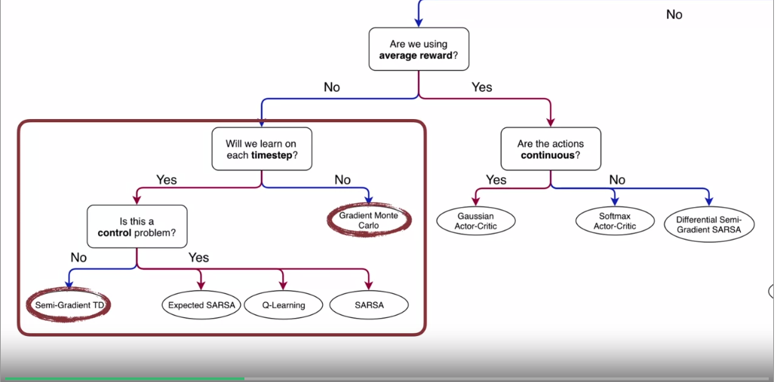
1021. .
1022. TD bootstraps using the value estimate and the next time step. So it does not need to wait until the end of an episode to learn.
1023. Now that we've got the big picture, let's do a quick recap of some of the details.
1024. We described a parameterized value function as a mapping from states to real numbers. The output is controlled by a vector of real valued weights W. We use the notation V hat of S and W to represent the approximate value function.
1025. .
1026. . 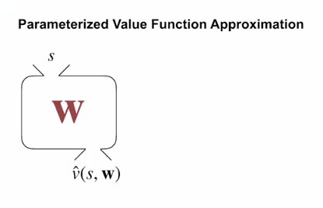
1027. This indicates that the value estimate is determined by the current state and the learn weight vector.
1028. One example of a parameterized value function is a linear function of fixed or expert design features.
1029. Another example is a neural network.
1030. We talked about two key properties of function approximation, generalization and discrimination.
1031. .
1032. Updating the value of one state can improve the value estimates of other states. This generalization can make learning faster.
1033. We also want our value function to assign different values when states are very different. We call this discrimination.
1034. .
1035. Next, we discussed how to use ideas from supervised learning to learn approximate value functions.
1036. .
1037. We cannot guarantee perfect approximation for every state's value. So we need to define an objective, a measure of the distance between our approximation and the true values.
1038. We use the Mean Squared value or objective. The sum of the squared error between the value of each state and our approximate value weighted by the visitation frequency Mu.
1039. .
1040. . 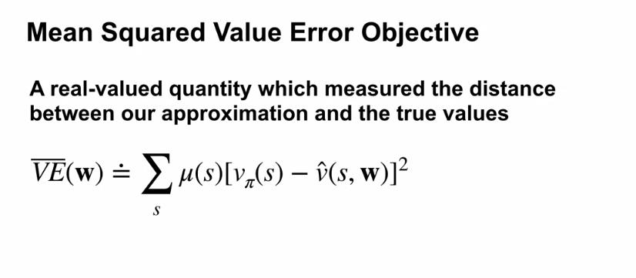
1041. .
1042. .
1043. We discussed how stochastic gradient descent can be used to optimize their objective.
1044. .
1045. The Gradient Monte Carlo algorithm performs stochastic gradient descent using sampled returns to update the weights. This means, it can learn approximate value from the experience generated by an agent interacting with the world. We also introduced semi gradient TD as an approximation to stochastic gradient descent.
1046. Semi-Gradient TD takes advantage of bootstrapping, and in practice may converge much faster than Monte Carlo. Semi-Gradient part of the name reminds us that it's not a gradient descent algorithm.
1047. Finally, we discussed the linear Semi-Gradient TD algorithm or TD with linear function approximation.
1048. Linear TD provably converges to a well-understood point.
1049. You now have a good foundation to understand reinforce learning with parameterized functions. Next, we will discuss different ways to construct state, and state action features. Until next time.